GRAND COUNTY, UTAH ORDINANCE #______________

AN ORDINANCE AMENDING GRAND COUNTY ZONING MAP FROM LARGE LOT RESIDENTIAL TO HIGHWAY COMMERCIAL FOR A 1.26-ACRE PROPERTY LOCATED AT APPROXIMATELY 1379 S ARNEL LANE, TAX PARCEL 02-0007-0168, GRAND COUNTY, UTAH.
WHEREAS, Mike and Ronnie McCurdy own a 1.26-acre property located at approximately 1379 S. Arnel Lane, Tax Parcel 02-0007-0168 in Grand County, Utah, in the Large Lot Residential Zone; and
WHEREAS, the McCurdys desire to change the zoning of their property from Large Lot Residential to General Commercial for a Housing Development; and
WHEREAS, the Grand County Commission unanimously passed an ordinance on December 17, 2024, Repealing and Replacing Section 6: Land Use of the 2030 General Plan, and the Future Land Use Map of Spanish Valley of the 2030 General Plan; and
WHEREAS, the General Plan Land Use Designation for the McCurdy parcel is Mixed Use/Flex Commercial; and
WHEREAS, the Mixed Use/Flex Commercial General Plan designation is translated in the plan to the Highway Commercial zone; and
WHEREAS, the McCury request complies with the officially adopted Future Land Use Plan for Spanish Valley; and
WHEREAS, the Planning Commission of Grand County held a duly advertised and noticed public hearing on November 24th, 2025, on the proposed change to the zoning map of Grand County, Utah, and carefully reviewed the proposed language, map and public input, and voted to forward the proposed ordinance to the Grand County Commission with a recommendation for [approval/denial]; and
WHEREAS, the Grand County Commission held a duly advertised and noticed public hearing on December 2nd, 2025, on the proposed zone change request and, after considering the public comments, the record, and the language of the Future land Use Plan, concludes that the amendment is consistent with the purposes and goals of the Grand County General Plan and the Grand County Land Use Code;

NOW THEREFORE, BE IT ORDAINED BY THE COUNTY LEGISLATIVE BODY OF GRAND COUNTY, UTAH, AS FOLLOWS:

SECTION 1: PLAIN ENGLISH SUMMARY OF THE ORDINANCE
This ordinance amends the Grand County Zoning Map for Mike and Ronnie McCurdy property, located at approximately 1379 S. Arnel Lane, Tax Parcel 02-0007-0168 in Grand County, Utah, from Large Lot Residential to Highway Commercial for housing development purposes.

SECTION 2: ZONE CHANGE
The Zoning Map of Grand County, Utah, shall be amended to change the zoning of the Mike and Ronnie McCurdy property, located at approximately 1379 S. Arnel Lane, Tax Parcel 02-0007-0168, from Large Lot Residential to Highway Commercial, consistent with the Future Land Use Map of the Spanish Valley, in Grand County, Utah. See Exhibit A and B.

SECTION 3: SEVERABILITY
Should any portion of this ordinance be found for any reason to be unconstitutional, unlawful, or otherwise void or unenforceable, the remainder of the ordinance shall be severable therefrom and shall remain in full force and effect.

SECTION 4: EFFECTIVE DATE
This ordinance shall become effective fifteen (15) days after the required publication thereof, as provided by Utah Code §17-53-208.
APPROVED by the Grand County Commission in public meeting this 16th day of December 2025, by the following vote:
Those voting aye: ___________________________
Those voting nay: ___________________________
Absent: ___________________________
GRAND COUNTY COMMISSION
_________________________________________
Bill Winfield, Chair
ATTEST:
_________________________________________
Gabriel Woytek, Clerk/Auditor
Exhibit A: Future Land Use Plan for Spanish Valley

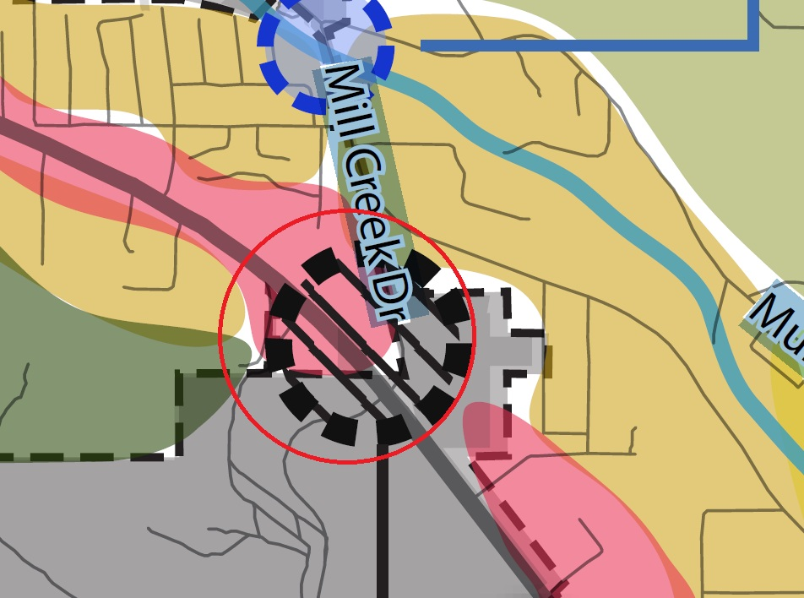
Exhibit B: Grand County Zoning Map 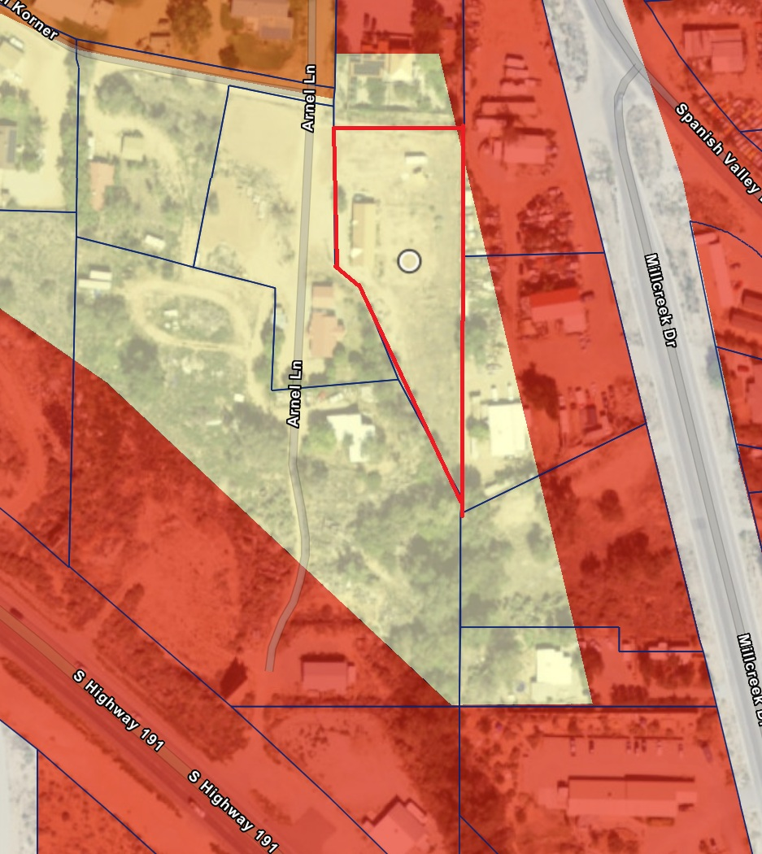

Legal Description: BEG AT A COR ON THE E LN SE¼ SEC 7 T26S R22E SLM SAID COR BEARS N 0°44'E 262.4 FT FROM THE SE COR OF SAID SEC 7 AND PROCEEDING THENCE N 28°10'W 164.5 FT TO A COR; THENCE N 22°06'W 124.2 FT TO A CEDAR FENCE POST; THENCE N 49°48'W 43.5 FT TO A COR; THENCE N 0°44'E 172.6 FT TO SW COR LILLIBRIDGE; THENCE S 89°16'E (REC=S 89°30'E) 161.0 FT TO THE SE COR LILLIBRIDGE N THE E LN SE¼ OF SAID SEC 7; THENCE WITH SAID LN S 0°44'W 458.7 FT TO BEG & CONT 1.13 AC. Parcel ID 02-0007-0168

