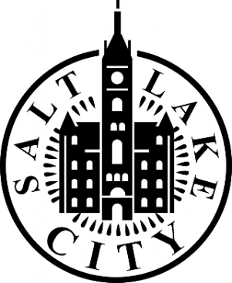

Accessibility and Disability Commission
Salt Lake City, Utah
Regular Meeting Agenda
November 13, 2025
3:00 p.m.
This meeting is a discussion among Commissioners and designated presenters.
Members of the public are welcome to attend. Please note that agenda items may be moved or discussed at different times during the meeting, depending on speaker availability and other circumstances.
Meeting Format
This will be a hybrid meeting. Attendees may join:
- In person at:
Salt Lake City & County Building
451 South State Street
CRA Room 118
Salt Lake City, UT. 84111
- Virtually via Zoom: https://us06web.zoom.us/j/81938088270?pwd=ZNmehXlbQezqxHYxR38tB8poR5g9rb.1
Public Meeting Rules
The Commission is committed to creating a respectful and inclusive environment where everyone feels safe participating in their government. Meetings should be conducted in an orderly, efficient, and dignified manner free from disruption, intimidation, or safety concerns.
To help maintain this environment:
- Disruptive behavior or comments will not be permitted.
- Threats or intimidation toward participants will result in removal from the meeting.
- All participants are expected to treat one another with respect and courtesy.
AGENDA
- Welcome
Roll Call
- Public Comment (Limited to 15 minutes)
  - Members of the public may provide comments related to the Commission’s work. Comments will be limited to two minutes of time.
- Approval of Minutes
  - Review and approval of minutes from September 2025 Commission meeting.
- Smith Entertainment Group Update (~15 minutes)
Overview of Smith Entertainment Group new development
Presenter: Addie McNamara
- ADA Parking Location 800 S. 300 W. (~15 minutes)
Discussion on recommendation for ADA parking spot location on 800 S. and 300 W.
Presenter:
Justin Haupt
- 2026 Accessibility and Disability Goals (~30 minutes)
Discuss focus and goals for 2026 to prepare for January meeting vote
Chair/Co-Chair for 2026 group discussion on role
Led by:
Angela Haylock
- City Updates (~10 minutes)
Led by: Angela Haylock, ADA Manager
Human Rights Day Wednesday, December 10, 2025 6:00-8:00 pm
NDEAM Proclamation
Congratulations Scott Browning- Ted Knowlton Leadership Recipient
Utah State Fairpark Meeting
Next Meeting: Thursday, January 22, 2026

TENTATIVE – Closed Session
The Commission may consider a motion to enter a Closed Session in accordance with Utah Code § 52-4-205. A closed meeting may be held for purposes such as:
- a. Discussing the character, professional competence, or health of an individual
- b. Strategy sessions regarding pending or imminent litigation
- c. Discussions related to security personnel, devices, or systems
- d. Investigative proceedings regarding criminal misconduct
- Any other purpose permitted under the Utah Open and Public Meetings Act

Certificate of Posting
I, the undersigned, duly appointed ADA Manager, hereby certify that the above notice and agenda was:
- Posted on the Utah Public Notice Website in accordance with Utah Code § 63F-1-701; and
- Posted at the physical location where this meeting will be held.
Angela Haylock
Salt Lake City Mayor’s Office

Reasonable Accommodation Notice
People with disabilities may request reasonable accommodation such as alternate formats, sign language interpreters, or other auxiliary aids and services. Please make requests at least two business days in advance.
To request accommodations, contact:
Email: ADA@slc.gov
Phone: 801-535-6235
Relay: 711

Presentation Slide decks:

