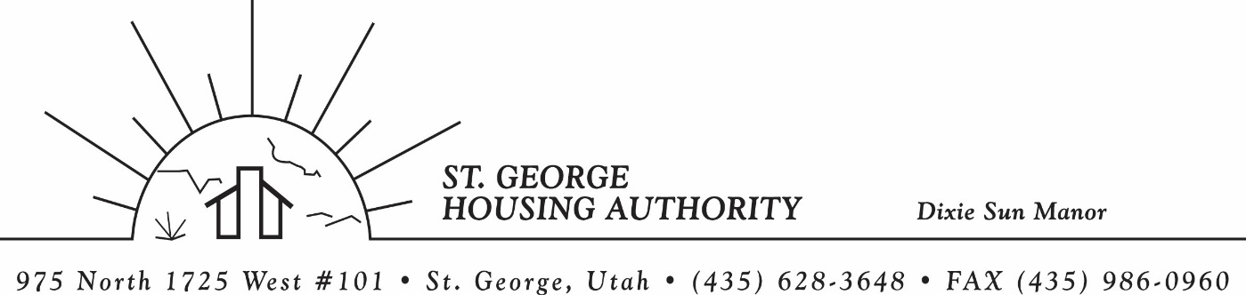
BOARD MEETING
DIXIE SUN MANOR 975 N. 1725 W. # 101
Tuesday October 14, 2025

PRESENT: Mike Barben, Kenny Miller, Jimmie Hughes, Jane Fehrenbacher, Tom Cover, Greg Whitehead, Ryan Dooley.

EXCUSED: Gloria Shakespeare

MINUTES: Minutes of Board Meeting held September 9, 2025 were reviewed. Motion made by Tom Cover to approve minutes as reviewed, motion seconded by Kenny Miller. Motion carried.

Review Housing Assistance Report for October 2025: Mike Barben handed out the HAP reports for October 2025. Board members were able to see the money spent for the months on rental assistance, see the average unit cost, and verify the units leased for the month. The board was also able to ask questions and have a discussion about portability, C of C, VASH, EHV, & Mainstream Vouchers. Each board member present signed off on the HAP payments and month end totals.

Report on Section 8 Waiting List Closing October 15, 2025: Mike Barben reported that on October 15, 2025 at 5 pm the Section 8 Waiting List will close. Mike reported that the waiting list has been open for approximately 6 weeks and close to 1000 applicants have applied so far.

REAC Submission Certification: Mike Barben reported that Fiscal year end 6/30/2025 Real Estate Assessment Center (REAC) was submitted and approved through the Financial Assessment Subsystem. Mike handed the report to the board members for review. Mike reported that SGHA was in good standing and all reporting has been submitted on time and approved.

Review current 2025-2026 budget: Mike Barben handed the board a copy of the fiscal year 2025-2026 SGHA budget. The board was able to see how the SGHA is doing in the current fiscal year budget. Mike reported that for the most part, SGHA was right on budget, and let the board ask questions on any of the items on the report. The board has asked Mike to provide and present the most recent budget accounts at each board meeting. By providing the current budget monthly, the board can see how the SGHA is keeping up with the current budget throughout the whole year. The board thought it would be great to ask questions and be on top of what the SGHA is doing financially. Greg Whitehead asked Mike if he could break the budget down into separate programs to verify which programs are doing well and which ones are needing help. Mike has now separated the budget into 3 programs so the board can better understand the flow of money in each program.

Update of admin updates from NanMcKay (Consulting Firm) for HOTMA & INSPIRE: Mike Barben reported that the admin update through Nan McKay was a success. Mike reported that he and his staff spent 6 days going through both the Section 8 Admin plan and also the Dixie Sun Manor Admin plan. Mike mentioned that the updates were very much needed and said that this update was really good for compliance. Mike said once the plan is finalized, he would give the board a copy of the plans for their review. The board seemed pleased with the report.

Update on training for SGHA staff and Board in Tennessee: Mike Barben reported that the MRI Conference training will be October 20-23. Two board members will also be attending the conference for training. Mike was able to give out flight plans to the attending board members. Mike reported that this conference will be a good training for all who attend.

Jane Fehrenbacker report on DSM: Jane reported that the community garden was thriving and doing well, except for the bottom of the raised garden collapsed. Jane reported that two unit have been filled. Jane reported that all DSM units have been re-piped and finished. Jane reported that DSM is a great place to live.

Report from Jimmie Hughes on City of St. George: Jimmie reported that a lot is going on in St. George this month including the reconstruction of the Dixie Bowl, a lot of new construction such as Costco, and In n Out Burger etc. Jimmie mentioned that the campaign process is going smoothly and will be over November 4, 2025. Board members were able to ask questions and discuss land issues and new and improved roads being put in St. Geoge. Great discussion.

Ryan Dooley Training: Ryan Dooley (St. George City Attorney) was present at the board meeting. Mike Barben reported that Ryan will be doing a board training at the next board meeting in November. Ryan will be training and certifying board members on Public Hearing procedures etc.

Motion made by Greg Whitehead to close the meeting. Kenny Miller seconded the motion. Motion carried. Meeting adjourned at 9:30 a.m. Next board meeting will be Wednesday November 12, 2025 at 8:30 am.

