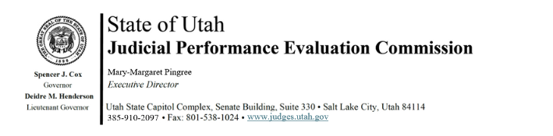
Thursday, November 13, 2025
9:00 am-12:00
Hybrid Meeting *

Members: Lisa Watts Baskin, Mallory Bateman, Christine Durham, Christian Hansen, Blair Hodson, Curtis M. Jensen, Gil A. Miller, Mary Noonan, Bridget Romano, Tom Ross, Mike Smith, Becky Edwards, Terry Buckner

Staff: Madison Klein, Julie Spilker, Chris Russell, Mary-Margaret Pingree

9:00 a.m. Welcome Bridget Romano
Approval of Minutes – Sept 8, 2025

9:05 a.m. Updates & Announcements Mary-Margaret Pingree

9:15 a.m. Unconscious Bias Training Tonia Wilson
Utah State Courts

10:15 a.m. Survey Updates Mary-Margaret Pingree

10:30 a.m. Deliberation Policies and Procedures Madison Klein
Bridget Romano
Paul Tonks
Chris Russell

11:15 a.m. Disclosures & Recusals Paul Tonks

11:25 a.m. Proposed Statute Changes Bridget Romano

11:45 a.m. Adjourn

Attachments: Utah Bar Journal Article (Nov/Dec) , Minutes – Sept 8 meeting, Proposed JPEC Statute Changes, Proposed Narrative Paragraph Changes, Judge List

Next Meeting: Tuesday, December 16, 2025
9:00 a.m. – 12 noon
Large Conference Room, 3rd Floor, Senate Building
*Anchor Location: Senate Building, Suite 330, CCJJ Large Conference Room

