DRAFT CITY OF OREM
DEVELOPMENT REVIEW COMMITTEE MINUTES
November 10th, 2025

The following items are detailed in these minutes:
- Preliminary and Final Plat – Pearson Subdivision - Located generally at 233 S 400 West - Approved
- Rezone – Home Depot - Located generally at 575 E 1000 South - Approved
- Approve the Minutes from the October 27th, 2025 meeting- Approve

Place: Aspen Conference Room (Floor 2) – City Hall Building – 56 North State Street, Orem Utah, 84057

11:01 a.m. Jared Hall called the meeting to order.

Those Present: Jared Hall, Chris Clements, Derek Spencer, Rick Sabey, Aaron McKnight, Taggart Bowen DRC Members; Grace Bjarnson Associate Planner

Those Excused: Steve Norman, Chelsea Lindsey, Darren Pead, Gary McGinn, DRC members; Rebecca Gourley, Associate Planner

- Preliminary and Final Plat – Pearson Subdivision - Located generally at 233 S 400 West in the he R7.5 zone
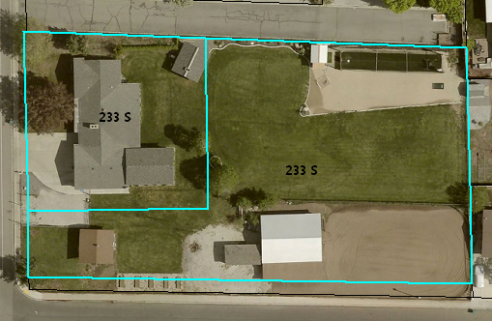
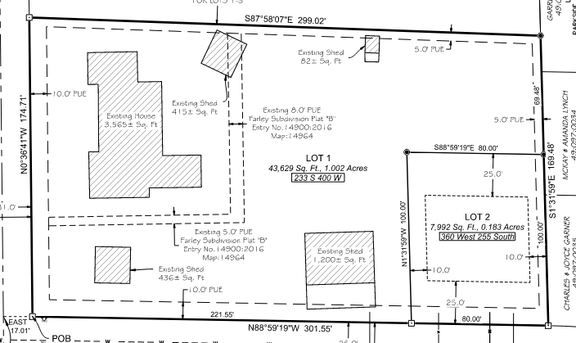

Grace Bjarnson presented the Pearson Subdivision preliminary and final plat. The left image is the current layout of the lots. The final plat will re-arrange the lot to create a two-lot subdivision.

DRC Action: Chris Clements motioned to recommend approval of the Pearson Subdivision Preliminary and Final Plat. Aaron McKnight seconded the motion.
Yes: Jared Hall, Chris Clements, Derek Spencer, Rick Sabey, Aaron McKnight, Taggart Bowen
No: None

- Zoning and Ordinance Map Amendment – Home Depot - Located generally at 575 East 1000 South in the R8 zone

Grace Bjarnson presented the zoning and ordinance map amendment to the northwest of where Home Depot is planning on being built. The applicant proposes to amend the zoning and ordinance map to change the residence located at 575 E 1000 South from R8 to PD34 to add to the property for the Home Depot project.
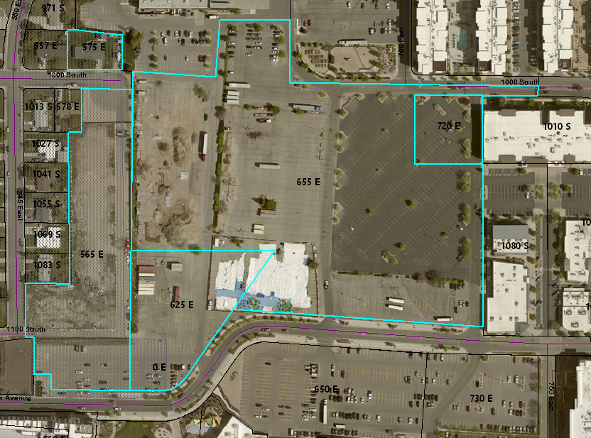

DRC Action: Rick Sabey motioned to recommend approval of the Zoning and Ordinance Map Amendment located approximately at 575 East 1000 South. Dereck Spencer seconded the motion.
Yes: Jared Hall, Chris Clements, Derek Spencer, Rick Sabey, Aaron McKnight, Taggart Bowen
No: None

- Approve the Minutes from the October 27th, 2025, Meeting
The minutes from the October 27th, 2025 meeting were previously sent out via email. No comments or questions regarding the minutes were presented.

DRC Action: Derek Spencer motioned to approve the minutes from the October 27th, 2025, meeting. Taggart Bowen seconded the motion.
Yes: Jared Hall, Chris Clements, Derek Spencer, Rick Sabey, Aaron McKnight, Taggart Bowen
No: None

- Adjourn:
DRC Action: Aaron McKnight motioned to adjourn the meeting. Chris Clements seconded the motion.
Yes: Jared Hall, Chris Clements, Derek Spencer, Rick Sabey, Aaron McKnight, Taggart Bowen
No: None

Adjourn: 11:08 a.m.
Approved On: Draft

