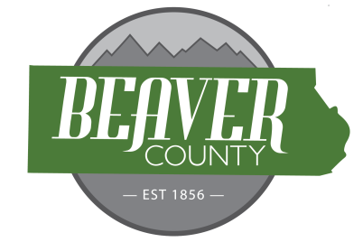
NOTICE AND AGENDA OF A PUBLIC MEETING
NOVEMBER 18TH, 2025 PUBLIC MEETING OF THE
BOARD OF COUNTY COMMISSIONERS OF
BEAVER COUNTY, UTAH

PUBLIC NOTICE is hereby given that the Beaver County Commissioners of
Beaver County, Utah, will hold a regular Meeting on November 18th, at the place
and time set forth below to consider the agenda item(s) hereinafter set forth.

MEETING PLACE: Beaver County Administration Building 105 East Center Street, Beaver, Utah.
MEETING TIME: 10:00 AM

10:00 AM
Open Meeting
Call to order
- Prayer offered by TBA.
- Pledge of Allegiance led by TBA
New Business
10:05: Approve Bills
10:10: Kirby Adams, Mel Clark. Gravel Pit RMA
10:20: Budget Request for Commission
10:30: CDBG Public Hearing
10:40: Budget Request for Children’s Justice Center
10:50: Budget Request for Fire Warden
11:00: Budget Request for Maintenance
11:10: Budget Request for Fair, Tushar, Minersville Lake
11:20: Budget Request for Treasurer
11:30: Adjourn Meeting

(To be discussed when/as time permits)

- Discussion Items
  - Conservation Easement with DNR at Puffer Lake

- Old Business
- Commission Updates

BEAVER COUNTY COMMISSION CHAIRMAN
Any other business properly brought before the Board.
Dated the 18th day of November 2025

