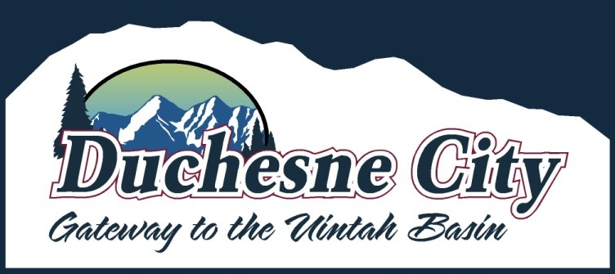

MUNICIPAL GENERAL POST-ELECTION AUDIT
Public Notice is herby given that an audit of the ballot batches designated by the State of Utah for Duchesne City regarding the 2025 Duchesne City General Election will take place at 4:30 PM on Wednesday, November 12, 2025, at the Duchesne City Office, 500 E Main, Duchesne, Utah. The public is invited to attend.

