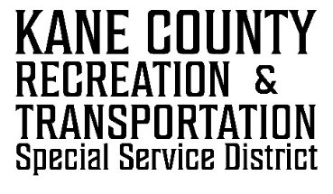
kcrtssd.specialservicedistrict.org

76 NORTH MAIN ST.
KANAB UT
84741

PUBLIC NOTICE IS HEREBY GIVEN that the Kane County Recreation & Transportation Special Service District of the State of Utah will hold a regular board meeting in the Commission Chambers at the Kane County Courthouse, 76 N. Main Street, Kanab, Utah on Wednesday, November 12, 2025 at the hour of 10:00 A.M.
November 12, 2025
WELCOME
- Call to Order
CONSENT AGENDA:

- Approval of 07-23-2025 RTSSD Meeting Minutes

REGULAR SESSION:

- Financials
- Budget overview and Discussion
- Review of the 2026 Tentative Budget
- Approval of the 2026 Tentative Budget (December- 7 day Notice)
- Set Public Hearing Date for Adoption of the 2026 Budget
- Checks disbursement

- Funding Requests
- None

- Other Discussion Items

- Adjourn

CLOSED SESSION:
- Discussing an individual’s character, professional competence, or physical or mental health.
- Strategy sessions to discuss collective bargaining, pending or reasonably imminent litigation, or the purchase, exchange lease or sale of real property.
- Discussions regarding security personnel, devices or systems.
- Investigative proceedings regarding allegations of criminal misconduct.

