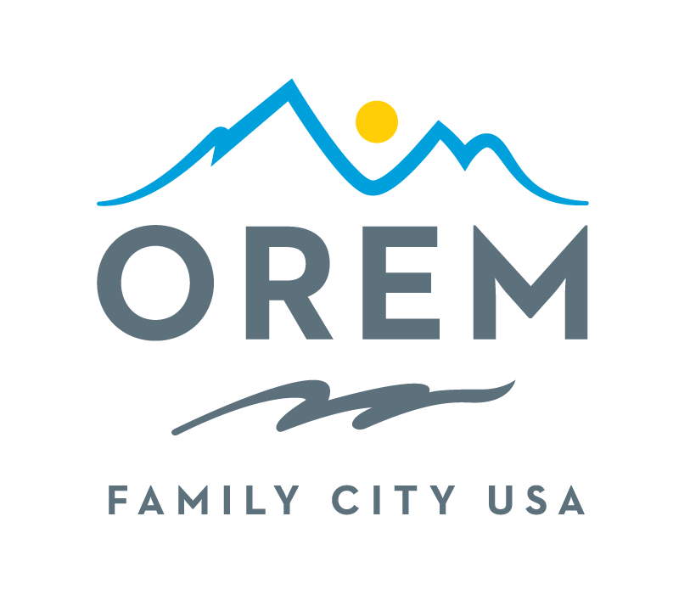
CITY OF OREM
ADVISORY BOARD/COMMISSION
MEETING AGENDA
meeting may be held electronically to allow a board/commission member to participate.
PUBLIC BODY: Events Advisory Commission
DATE: Thursday, November 13, 2025 ROOM: City Council Conference Room #1002
Right next to the City Council Chambers
TIME: 4:00 p.m. - 5:30 p.m. ADDRESS: 56 North State Street, Orem, Utah

AGENDA ITEMS:

Welcome Ashlie Mann
Review and Approve Minutes from October 9, 2025 Ashlie Mann
- City Updates
  - Orem Plaza Update Bryce Merrill
  - Community Events – The Healer Nativity Kenice Whitaker
  - Thank You Kenice Whitaker
    - Truck and Treat Help (Paula’s volunteers)
    - Truck or Treat help/support
    - Veterans Day
  - Save the Date (January 23, 2026) Volunteer Banquet Award Sydney Bailey
  - Action Commitment Reporting Kenice Whitaker
    - Lights On – Updates during discussion Kenice Whitaker
  - Asks Kenice Whitaker
    - Lights On – Help & Support
    - Commission Recruitment Window – Encourage Applicants
  - Commission Updates Ashlie Mann
- Commission Updates Ashlie Mann
  - Action Commitment Reporting
  - Lights On Updates during discussion
  - Asks
- Discussion Items
  - Veteran[s Day Report & Evaluation Rodney Gardner
  - Lights On Updates during discussion
    - Wreath Auction Kami Burgess
    - Kids Activities Christie Ekins
    - Lights On Ornament Krista Tate
    - Stage Entertainment Sydney Bailey
    - Photo Ops Kenice Whitaker

- Review Action Commitments Kenice Whitaker
Next Meeting – Thursday January 8, 2026 Ashlie Mann
Adjournment Ashlie Mann

THE PUBLIC IS INVITED TO PARTICIPATE IN ALL CITY MEETINGS.

If you need special accommodation to participate in Advisory Commission meetings
Please contact us on the City's website at orem.org or call (801) 229-7000 at least three working days.
prior to the meeting. This agenda is available on the Utah Public Notice website at utah.gov/pmn.

