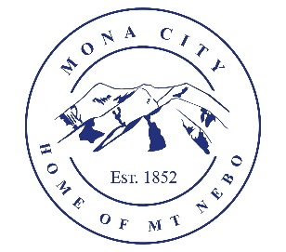
Mona City
435-623-4913
www.Monautah.gov
20 West Center Street, Mona, Utah

Mona City Council Work Session
Tuesday, November 18, 2025
6:00 pm
Mona City Council Room – 20 West Center

Notice is hereby given that the Mona City Council will hold a work session on Tuesday, November 18, 2025, at 6:00 p.m. in the Mona City Council Chambers at 20 West Center Street, Mona City. The purpose of the work session is to discuss the following:

- Presentation by Life Balance Recovery Facility

- Discussion of the use of park impact fees and the application of the LWCF Land and Water Conservation Fund Grant

CERTIFICATE OF POSTING

This agenda is hereby properly advertised on the 5th day of November 2025, by posting copies of this agenda at the Mona City Office, at the United States Post Office located in Mona City, on the Mona City website at monautah.gov, and on the Utah Public Notice Website at www.utah.gov/pmn/index.html.

_______________________________________
Alicia Hills
Mona City Recorder

Upon Request, in compliance with the Americans with Disabilities Act, reasonable accommodations for individuals with disabilities will be provided. For assistance, please call 435-623-4913.

