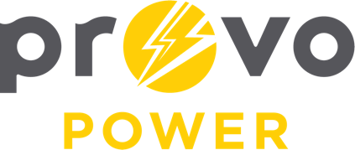
AGENDA
ENERGY BOARD MEETING
PROVO POWER
251 W 800 N
Monday, November 4, 2025
4:00 P.M.

- Welcome & Introductions – Chairman Gary Winterton
- Review & Approval of Minutes – September 8, 2025
- Review & Approval of 2026 Calendar – Chairman Gary Winterton
- Financial Report – Charlie Little
- KPI Report – Charlie Little
- Manager Report – Scott Bunker
- Period for Public Comment
- Calendar & Scheduling
  - Next Board Meeting: January 2026
  - Thanksgiving Luncheon: November 12, 2025
  - Christmas Luncheon: December 10, 2025

A copy of the agenda was posted in the Civic Center, and the Provo City Library, on October 30, 2025, and also delivered to the Mayor,
City Council Members, required news media, and adjacent cities in
compliance with the Utah Code 52-4-202

