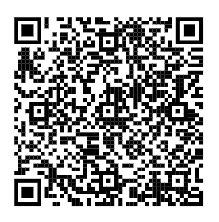
Salt Lake County NMTC, Inc.

Board Meeting Agenda
Location: Remotely via Webex using the link below:
https://slco.webex.com/slco/j.php?MTID=m3c546230e07f9e514cb9feafeaa53d21
Date: Thursday, November 6, 2025
Time: 4:30 pm

Motions relating to any of the items listed below, including final action, may be taken.
Individuals wishing to comment electronically must access the meeting using the Webex link above by the beginning of the “Citizen Public Input” portion of the meeting. Comments will be limited to three minutes per individual unless otherwise approved by the Board. If an individual is unable to attend the meeting via Webex, they may email their comments to KrJensen@saltlakecounty.gov by 9:00 AM the day of the meeting to have those comments distributed to the Board and read into the record at the appropriate time.
The first time you join via the link may take longer to get through the set-up steps. Please plan accordingly. Please include "Resident" ahead of your first name when you join the meeting, or you will not be identified as wanting to give comment.

Agenda Items
1. | Introduction and Citizen Public Input | Jenny Wilson, Chair
2. | Approval of meeting minutes – 12/10/24 | Chair Wilson
3. | 2025 Adjusted Budgets – Kearns Library LLC & Salt Lake County NMTC, Inc.: for approval | Darrin Casper and Greg Folta
4. | 2026 Recommended Budgets – Kearns Library LLC & Salt Lake County NMTC, Inc.: for approval | Darrin Casper and Greg Folta
5. | 2024 Form 990, Exempt Organization Tax Return: for approval | Darrin Casper and Greg Folta
6. | Other business/schedule next board meeting (budget adoption - December 16, 2025) | All

