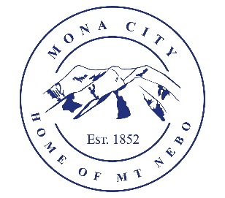
Mona City
435-623-4913
www.monacity.gov
20 West Center Street Mona, Utah

City Council Public Hearing Notice
Tuesday, November 18, 2025
7:00 pm
City Council Room, 20 W. Center St.

Notice is hereby given that the Mona City Council will hold a public hearing on Tuesday, November 18, 2025, at 7:00 p.m. in the Mona City Council Chambers located at 20 West Center Street, Mona City. The purpose of this hearing is for the following:

- Resolution 2025-26: Fee Schedule Update
  - Increase of sewer impact fee on new builds to $5,500, per ERC

CERTIFICATE OF POSTING

This agenda is hereby properly advertised on this, the 30th day of October 2025, by posting copies at the following places: the Mona City Office, at the United States Post Office Mona City Branch, on the Mona City website at monautah.gov, and on the Utah Public Notice Website at www.utah.gov/pmn/index.html.

________________________________________
Alicia Hills, Mona City Recorder

Upon Request, in compliance with the Americans with Disabilities Act, reasonable accommodations for individuals with disabilities will be provided. For assistance, please call 623-4913.

