N O T I C E

PUBLIC NOTICE IS HEREBY GIVEN THAT THE JUAB COUNTY COMMISSIONERS OF JUAB COUNTY, UTAH, WILL HOLD A PUBLIC HEARING ON OCTOBER 30, 2025, AT THE PLACE AND TIME SET FORTH BELOW TO CONSIDER THE AGENDA ITEMS(S) HEREINAFTER SET FORTH.
PUBLIC COMMENT WILL BE LIMITED TO THREE MINUTES.

LOCATION: Juab County Administration Building, 160 North Main, Nephi, Utah
TIME: 6:00 p.m.

AGENDA
6:00 p.m. Welcome

Public Hearing for Truth in Taxation and Proposed Increase on Property Tax Revenue

Juab County intends to levy a tax rate that exceeds the calendar year taxing entity’s certified tax rate.
Amount: $325,000
Purpose: To address rising wages, material costs, and operational expenses. This adjustment will ensure fiscal stability, sustain essential services, and maintain the capacity to meet current and future obligations

Presentation by John Crippen

In-Person Comments – Comments will be limited to three minutes.

Virtual Comments from Teams Meeting – Comments will be limited to three minutes.

Adjourn Public Hearing

Attested to this 29th day of October 2025
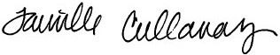

Tanielle Callaway
Juab County Clerk/Auditor

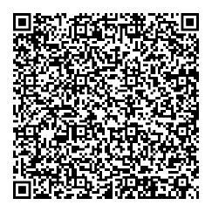
Click on the QR code for the online
Meeting link for Public Hearing.

