CITY OF OREM
DEVELOPMENT REVIEW COMMITTEE MINUTES
October 27, 2025

The following items are detailed in these minutes:
- Administrative Approval - Chor Carport - Located generally at 1433 West 130 South
- Text Amendment - Padel Den - Located generally at 1440 North 1380 West.
- Plat Amendment - Deerfield- Located generally at 1021 West 40 South
- Final Plat - Maag Final Plat - Located generally at 537 North 500 West
- Plat Amendment - Taylor Park Plat B - Located generally at 105 W Hidden Hollow Drive
- Approve the Minutes from the October 13th, 2025 meeting

Place: Aspen Conference Room (Floor 2) – City Hall Building – 56 North State Street, Orem Utah, 84057

11:02 a.m. Jared Hall called the meeting to order.

Those Present: Jared Hall, Chris Clements, Derek Spencer, Rick Sabey, DRC Members; Rebecca Gourley, Associate Planner

Those Excused: Taggart Bowen, Steve Norman, Chelsea Lindsey, Aaron McKnight, Darren Pead, Gary McGinn, DRC members; Grace Bjarnson, Associate Planner

- Administrative Approval - Chor Carport - Located generally at 1433 West 130 South in the M2 zone

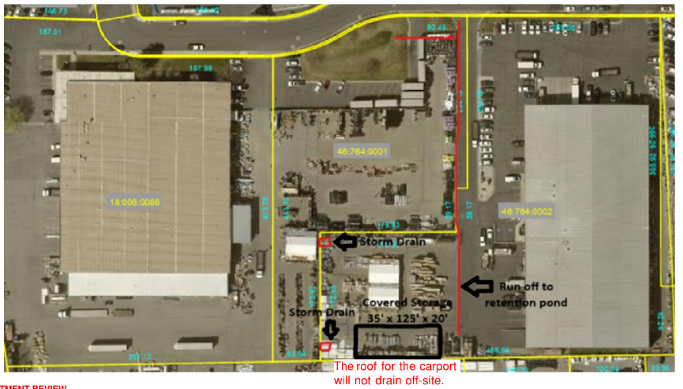
Rebecca Gourley introduced the administrative site plan approval for the Chor Carport at 1433 West 130 South. The applicant proposed to build a 35’x 125’x 20’ carport for storage. The site has two storm drain accesses and no off-site water runoff. The plan complies with all applicable code.

DRC Action: Chris Clements motioned to approve the Chor Carport Administrative Site Plan. Rick Sabey seconded the motion.
Yes: Jared Hall, Chris Clements, Derek Spencer, Rick Sabey
No: None

- Text Amendment - Padel Den - Located generally at 1440 North 1380 West in the PD-36 zone
Rebecca Gourley presented a text amendment request to add SLU 7425 (gymnasiums and athletic clubs) to the approved uses in the PD36 zone, located generally at 1440 North 1380 West. The request was forwarded to the Planning Commission.

DRC Action: Derek Spencer motioned to forward the Padel Den Text Amendment to the Planning Commission. Rick Sabey seconded the motion.
Yes: Jared Hall, Chris Clements, Derek Spencer, Rick Sabey
No: None

- Plat Amendment – Deerfield Park Plat C - Located generally at 1021 West 40 South in the R6.5 zone

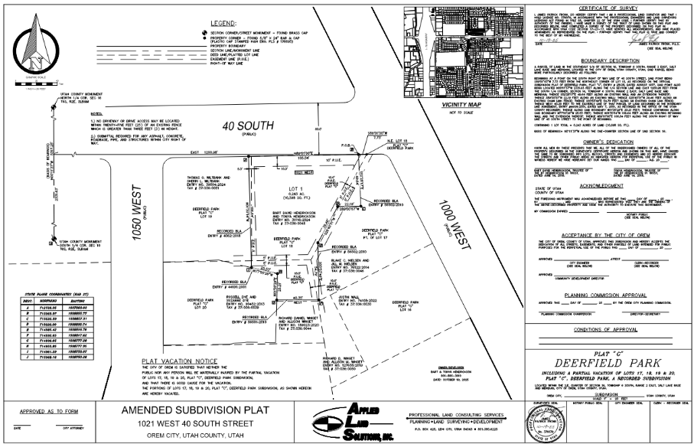
Rebecca Gourley presented the plat amendment for the Deerfield Park Plat C project. The applicant requests a plat amendment to adjust property lines to reflect recent land purchases. No changes were proposed to the public utilities easements (PUEs). The plat amendment complies with all applicable code.

DRC Action: Rick Sabey motioned to approve the Deerfield Park Plat C Plat Amendment. Derek Spencer seconded the motion.
Yes: Jared Hall, Chris Clements, Derek Spencer, Rick Sabey
No: None

- Final Plat - Maag Final Plat - Located generally at 537 North 500 West in the R7.5 zone

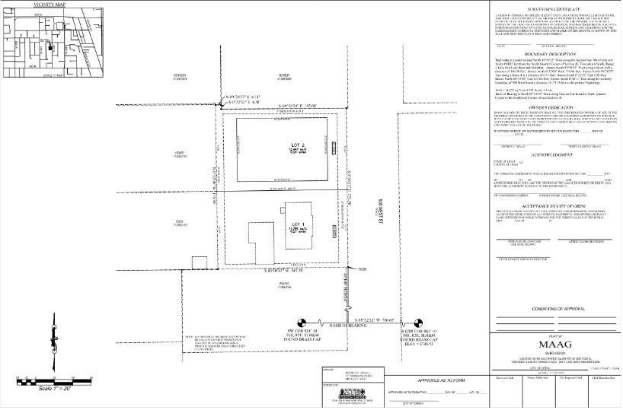
Rebecca Gourley presented the Maag final plat. This is the final plat of the Maag Plat A subdivision, which is set to be reviewed at the Planning Commission on November 5th, 2025. The final plat will split the parcel to create a two-lot subdivision.

DRC Action: Chris Clements motioned to approve the Maag Plat A Final Plat. Rick Sabey seconded the motion.
Yes: Jared Hall, Chris Clements, Derek Spencer, Rick Sabey
No: None

- Plat Amendment - Taylor Park Plat B - Located generally at 105 W Hidden Hollow Drive in the R8 zone

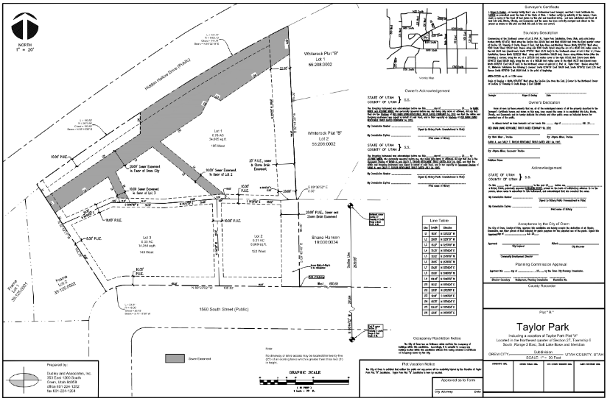
Rebecca Gourley presented the plat amendment for Taylor Park Plat B. The applicant proposes to amend the plat to reflect existing ownership lines and rectify previous land purchases. No changes to the PUE have been proposed.

DRC Action: Derek Spencer motioned to approve the Taylor Park Plat B Plat Amendment. Rick Sabey seconded the motion.
Yes: Jared Hall, Chris Clements, Derek Spencer, Rick Sabey
No: None

- Approve the Minutes from the October 13th, 2025, meeting
The minutes from the October 13th, 2025 meeting were previously sent out. No comments or questions regarding the minutes were presented.

DRC Action: Rick Sabey motioned to approve the minutes from the October 13th, 2025, meeting. Derek Spencer seconded the motion.
Yes: Jared Hall, Chris Clements, Derek Spencer, Rick Sabey
No: None

Adjourn: 11:07 a.m.
Approved On: DRAFT

