Online Attendees: Robert Sampson (Community Services), Talia Butler (Public Works), Rashelle Hobbs (Recorder), Cynthia Archuleta (Sheriff), Megan Hillyard (Administrative Services), Sheila Srivastava (Treasurer), Dave Delquadro (Council)
In-Person: Chris Stavros (Assessor), Richard Jaussi (Auditor), Katy Fleury (Mayor Administration), Brad Park (Surveyor), Zachary Posner (Information Technology), Lisa Ashman (District Attorney)
Representation Absent: Clerk, Human Services
Staff: Tony Jolley-online, Rina Shipley-online, Andrew Dudley-online, Lee Wilstead-in-person, Mark Miller-in-person, Mike Bailey-online, Trevor Hebditch-in-person, Cherie Root-in-person, Brandon Allgier-online, Thomas Yeung-online, Sam Sedivec-online, Kimball Ball-online, Valina Eckley-online, Wendy Ormsby-in-person
TOPIC | POINTS OF INTEREST
Welcome & Remote Meeting Instructions | Brad Park opened the meeting. Because there are not any GIS items requiring a vote, this meeting will be considered informational for GIS Steering.  Trevor Hebditch shared the following slide:  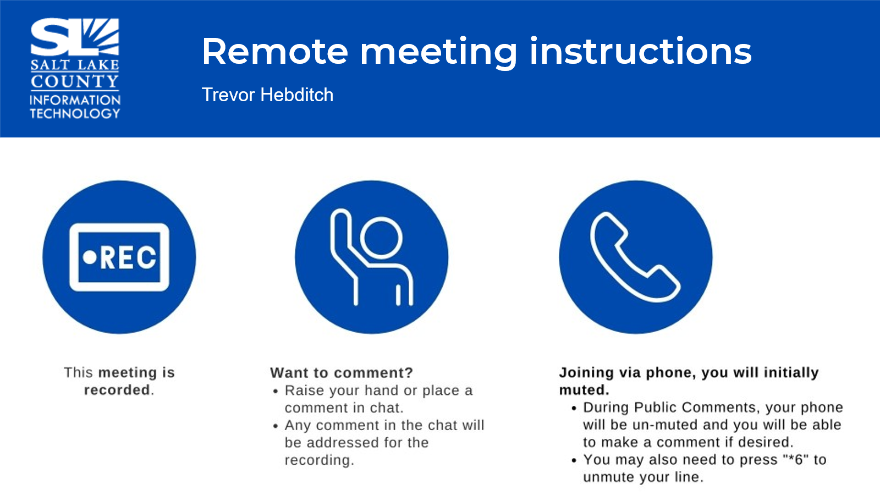
Public Comments  (Brad Park) | None.
Approval of minutes from June 26, 2025, meeting | Motion to approve the minutes by Chris Stavros, Richard Jaussi seconds the motion. No discussion.  Motion passed unanimously.
Follow-up Items  (Cherie Root)  Today’s meeting is focused on budget, so all follow-up items will be discussed at a future date. | 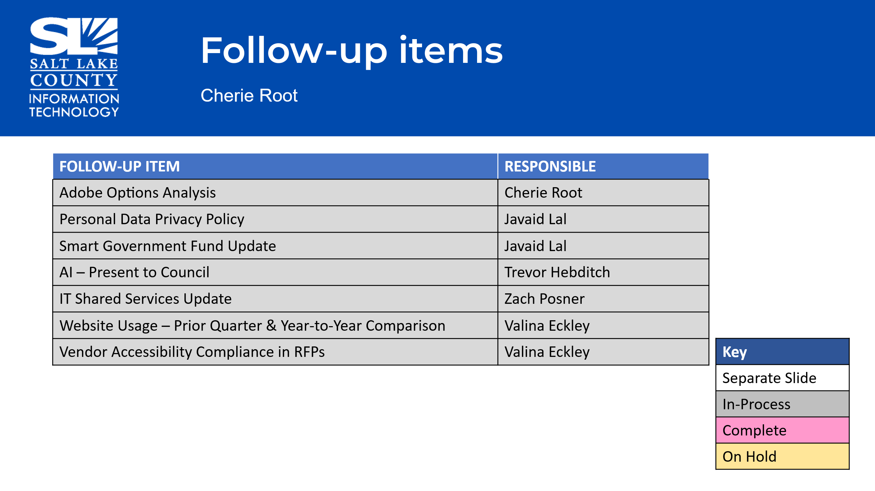
GIS Steering Items.  (Lindsy Bentley)  GIS Steering Items.  (Lindsy Bentley)  Cont. |   STWG  - ESRI User Conference  https://storymaps.arcgis.com/stories/a875fb9b34de458bad39c67042b20ad9  - STWG Analysis: Mark Miller is helping guide the group through a STWG analysis, and they  are still working through the results.  - County GIS User Group Meetings: Restarting quarterly, with the first one in September.  Invites sent to 158 people with ESRI licenses, but open to anyone.  - ESRI User Conference:  - Held in San Diego, the largest GIS conference in the world.  - In 2024, roughly 23,000 people attended in person and about 16,000 attended  digitally from over 130 countries.  - Over 200 vendors in the expo center.  - Over 150 technical sessions.  - AI was a major theme of the conference.  - AI was able to create a hydrant inspection form and fill it out based on photos.  - QR code included for transparency and trust cards.  - Upcoming Changes:  - In the 12.0 release, Web App Builder, Configurable Apps, Map Viewer Classic,  Dashboard Survey 123, DataStore, Tile Cache Datastore, and the Metadata Editor  Classic are being replaced.  - These are being replaced by Experience Builder, Instant Apps, Map Viewer, and  NextGen Survey123.  - The County has 10 free in-person registrations for the user conference.  - Register early (December/January) to secure hotels within walking distance.  - Attending in person allows collaboration, access to technical sessions, and hands-on  workshops.  - ESRI Licensing:  - A screenshot of the ESRI licensing dashboard was included to show the number of  users within the County.  - A survey was sent to 114 GIS users within the county to identify power users and  conduct a needs assessment; 29 have replied.  - 34 people have signed up for the user group meeting.  - A display will be done during Geography Week in November.  - Departments are encouraged to show how they are using GIS.  Committee Discussion Notes  - The tax offices have a lot of power users of GIS and ESRI technology.  - There is a need to demonstrate the value of ESRI at an executive level.  - Shykell asked if there was a system in place for determining who gets one of the 10 free  attendees.  - The process is to request it through STWG, which then goes to the GIS steering  committee.  - The license is free, but travel is not.  - Shykell can send an email to STWG.
Budget  (Zachary Posner)  Budget  (Zachary Posner)  Cont.  Budget  (Zachary Posner)  Cont.  Budget  (Zachary Posner)  Cont.  Budget  (Zachary Posner)  Cont.  Budget  (Zachary Posner)  Cont. |   TAB 2026 Priorities.xlsx  Working Group Updates  - The presentation will follow the PWG ranking order.  Hardware and Software Maintenance Increase:  CPI shows about a 25% increase in inflation over the past 5 years.  Received about a 4.5% increase in the overall operating budget.  Requesting a large amount to maintain existing systems.  Critical Mainframe Tax Support:  Taking a belt and suspenders approach to long-term maintenance of the mainframe. Peggy has been training junior staff in mainframe programming. Seeking funding for managed services for mainframe support.  Disaster Recovery:  Requesting an increase to maintain the existing disaster recovery infrastructure.  Tax Modernization Program:  About to expire over $400,000 of ARPA/TI funding. Dave wants to get in front of the Council on the TORUS project as a whole.  MS ISAC Membership  Intelligence sharing and partnership with other states, local, tribal, etc. around cybersecurity and cyber technology. Funded through CISA (Cybersecurity Infrastructure and Security Agency), part of the Department of Homeland Security. Federal Funding has been cut. Combining MS ISAC and EISAC (specific to elections) to serve vulnerability and attacks in the election space and general infrastructure.  Password Quality  Seeking to increase password quality across the board.  Certificate Management System  Certificates are expiring more frequently (now about a year, potentially moving to 45-50 days). Automating this system would prevent needing a full-time employee to update certificates. Security Information Management System (SIEM) gathers log data from critical systems (firewalls, databases, laptops, etc.) and correlates it to look for threats. A previous system was built on open-source tools but was not maintainable. Seeking funding for a commercial product to avoid building and maintaining it in-house.  Cybersecurity Engineer FTE Request  Need more support due to the shared services model and security reviews of SaaS and third-party products. Requesting an additional analyst to help with the workload.  Quality Assurance FTE  Proven valuable in terms of development speed and product quality for TORUS project. Seeking full-time funding for this critical function division-wide.  Privilege Access Management  Aims to secure administrative work on systems through secure password management and temporary passwords. Provides temporary passwords for critical systems that expire after use. Current on-premise system is clunky and needs an upgrade.  Social Media Archiving Software  Maren brought this to our attention for records and archiving a few years back. Used for archiving county social media for GRAMA requests and long-term storage. Previously funded under ARPA, but funds are expiring.  SharePoint Modernization  Becoming super dependent on SharePoint across the County. Current hybrid system is restrictive and hinders expansion. Moving to the cloud would address storage issues and enable better use of cloud services. This is independent of the hardware and the software maintenance request.  Security Compliance Analyst  Increasingly being asked to advise on compliance (HIPAA, PCI etc.). Lack of significant in-house expertise committed to this. Need someone to understand and help navigate compliance for the County.  County Privacy Officer  Seeking funding through the Mayor’s office and Administrative Services. To help with the GDPA (Government Data Privacy Act). Legislation is good but unfunded, requiring a full-time position to handle constituent and employee data privacy.  Business Analyst FTE  Similar to the quality assurance analyst but ranked lower. Business analysts are overbooked. They help accelerate software development and implementation of applications.  SLCO Accessibility Compliance Tool  Aims to ensure systems are accessible to constituents, following the Plain Writing Act of 2010. Targeting a 5th-grade reading level for website content. Plain language is easier to translate.  Web Experience Analyst  Currently a temp. position. Recommends testing and helps maintain web standards. Bolsters action and maintains quality and web standards.  Job Description Management Software  Current system involves a giant folder with 20 years of job descriptions. Seeking a system for version control, understanding job descriptions over time, and workflow management.  Smartsheet Licensing Model Change  Smartsheet is increasing prices next year, probably by about 15%. “Smartsheet was purchased by private equity in January…they reduce support and increase cost.” Deeply embedded in the platform.  Job Descriptions & Market Analysis  Stephanie Ross (HR Business Partner Manager) and Julene Elgueta (Compensation Manager) discussed job description and market analysis. The new system will be part of the program used for market analysis, streamlining the review of jobs every three years. Compensation is based on job description, so it’s important to pay people appropriately based on what they’re really doing. The software implemented has a job description management piece, which allows for comparing job descriptions, maintaining equity, and standardizing language.  Risks of Current System  Risks of the current system include accidentally saving over previous versions, deleting files,  or moving folders. Many departments use job descriptions, so consistency is important. Updating job descriptions manually is time-consuming and prone to errors. Example: Adding background check information required manual updates to every job description. The current system is considered archaic.  Pay Factors Software  The software is Pay Factors, which is already used for market analysis. Pay Factors has a job description option. The software meets current needs, but the county may consider other options in the future. (Nilsa’s Comments: Nilsa stated that job descriptions have been a problem for agencies since 2011. Managing job descriptions takes a lot of time and energy.) Other priorities, such as ePARs and onboarding, have taken precedence. Managers will be able to review job descriptions via email. Active job descriptions will still be available on the website. Access to all job descriptions in the software will be assigned. The system tracks changes and who makes those changes.  Privacy Officer  Megan raised concerns about the need for a dedicated privacy officer. The concept of a privacy officer was introduced years ago and is now mandated by the State of Utah. Javaid is currently serving as the de facto data privacy officer. The emergence of AI technology and security concerns make this role increasingly important.  Prioritization of Privacy Officer Role  The privacy officer role was ranked number six on the IT list. Zach stated that the ranking was primarily because it is a mandate. Richard also stated that the sixth ranking should be reconsidered.  Javaid's Comments  Javaid Lal stated that the designation comes with lots of work and may require multiple people. Privacy and security go hand in hand.  IT Perspective  IT ranked the privacy officer role higher because they already have staff doing security work, but no one dedicated to privacy.  - Quality Assurance FTE  Chris asked about the Quality Assurance FTE.  Zach stated that they have someone in a TL position doing this for the TORUS project and so they're able to draft off that. Trevor spoke about the importance of the Quality Assurance FTE. The amount of work the time-limited individual is doing is overwhelming. Making the position merit would mitigate the risk of him leaving. The role could be expanded to support the web team and other projects.  - Ranking Discussion  The committee discussed ranking the items on the list. Chris asked if there were tiers or if the committee had thought about what would be cut if they didn't get all the funding they requested. Zach stated that it depends on the amount of funding received. If they receive less funding, they may have to cut back on existing spending or take on additional risk.  - Smartsheet  Smartsheet increase for the entire County isn't in maintenance.  - Top Four  The committee is asked if anyone has a problem with the top four or sees it differently. The really big-ticket items tend to take all the air out of the room.  - MS-ISAC  The opinion is to leave it where it is with the hope that it gets funded by the State.  Process Question  If the line of what gets funded is much higher this year than hoped, is there any chance of lessening the maintenance number one to get some of the other priorities funded? Last year, there was a lot of back and forth because the committee is a recommending body to the Mayor’s office, which is a recommending body to the Council. Darrin or Rod are going to ask what the critical things are that the committee would get rid of first as a maintenance line.  Password Management System  The committee discusses whether the password management system should be number six.  Data Privacy  A suggestion is made to pull the data privacy back up because of how the committee recommends things is significant from a policy priority perspective. The smaller items can be played around with if some of the other things get funded.  Dave Delquadro reminds the committee that what Mayor's Finance often does, especially for organizations like independent elected officials, is they say, "look, you ask for X, we can afford 33% of X, here's your budget. Spread it any way you want." He suggests that the committee consider a consensus or a TAB meeting motion that says if the number proves to be unsustainable; this is the approach the committee would like to consider. There needs to be some kind of recognition that "we're going to have to tighten the belt someplace in order to get relief in the areas that you're talking about."  Budget Items  Outside of number one, which is the overall maintenance, everything else is either identified to a potential vendor with a cost or the committee knows salary, benefits, and equipment. It's really all or nothing on every line item but one.  Number One  The committee might look at what can be turned off that wouldn't hurt as much. The TORUS project ask has contractor headcount and other things that could be cut, but  the risk of that is terrible because it will extend the time to deliver on that project.  Rina on Certificate Management System  Rina believes the certificate management system is more important than the password management system. Certificates are going to be expiring every 45 to 50 days in about three years, and there is no way to manage that manually. We only have one expert in certificates, so the committee needs to get an automated system in place in case that person leaves with all of his knowledge.  SharePoint Modernization  Chris would like Lee and Mark to elaborate on the SharePoint modernization because it's a critical document system and a driving force behind the BOE and document management. Instead of using SharePoint on prem, the proposal is to move just the documents that are being touched on a regular basis to SharePoint in the cloud, and anything that is just for retention historical that is not going to be touched anytime soon, put that in cold storage. If that doesn't get approved and the committee stays with a hybrid, it's a lot more costly in the sense of equipment with fire, and the committee has to support seven total servers, all the software that goes with that, etc., and it's maintaining two different ways of automating the processes. More and more agencies are moving towards this technology based on the fact that the committee owns a lot of the software as part of their Office365.  Chris's Thoughts  Chris thinks SharePoint should move up in the list and that the quality assurance FTE is ranked too low because people need to remember that in order to migrate away from the mainframe, the committee has to successfully implement all the tax system projects. Chris agrees with Rina that certificate should go above the password management system.  SharePoint  SharePoint modernization is probably the bigger deal because the committee is committed to that system. If the committee is not fully funding it or funding it appropriately, they're going to end up with a ton of shadow IT.  Password Management  The committee has agreed to move password management down and certificate management up. The committee should move SharePoint up.  Social Media Preservation and Retention  Social media preservation and retention is mandated by GRAMA. Social media archiving is more of accessibility and compliance with records law. The committee needs to stay in compliance with records law.  HR's Project  The committee needs to move HR's project up. If the committee is serious at all about EPIC performance management, market studies on jobs, let's give them a system that they can manage this properly.  Job Description Maintenance  Suggest evaluating SharePoint workflows and other document management as an interim solution. Notes that SharePoint was used in the past with HR, but its viability needs to be reassessed. Past implementation was "patchwork" and didn't integrate with current systems.  Sorting Discussion  Discussion on sorting data with TAB and then a secondary sort. The committee is trying to sort by IT priority. The committee is working to re-rank the IT priorities.  Separate Funding Requests  IT: Requesting a telecom increase from $22 to $24 per line per month (no increase in nine years). Telecom is an ISF (Internal Service Fund) as opposed to general fund dollars.  - Clark Planetarium: Dome projector is end-of-life and a revenue generator. IMAX theater upgrade needed within two years.  - Facilities: Capital project management software needed, especially with the move to the new building.  - Arts and Culture: Event management software needed for planning events and building facility diagrams.  - Cellular Distribution: Extending cell service to areas with poor reception in certain facilities.  - Clark Planetarium website redesign has been pulled.  - Sorting Separate Funding Requests  Discussion on the ranking of the separate funding requests.  Existing Funding  Overview of existing funding requests.  - IT: Alternatives to Adobe are being explored due to increasing costs.  - IT: Seeking $10,000 to explore test cases for use with AI.  - Civic Plus Board application: Ongoing funding.  - New body scanners for the jail system.  - Library: Network design and analysis application.  - Library: Real-time data visualization (similar to IT's SIEM).  - Library: Service management system (alternative to POB recommended).  - Library: Search and discovery software (catalog system upgrade).  - Library: Communication application for constituent alerts and notices versus another tool for internal messaging.  TAB 2026 Priorities.xlsx  Motion and Vote: Motion made by Richard Jaussi to recommend the rankings as outlined. Caveat to be prepared to give options dependent on recommended budget. Chris Stavros seconds the motion.  No further discussion.  Motion passed unanimously.
 | No closed session was needed at this meeting.



Communication item: Priorities will be passed along.

Appreciation
- Appreciation for the governance in the organization.
- Compliments to staff for their preparation and recall of project details.

Upcoming Meeting Schedule  (Wendy Ormsby)  *Please note the August 21st meeting not needed, canceled. |     9:00 – 10:30 a.m.  - October 23  - December 11
Review Action Items (Wendy Ormsby) |   No new action items.
Next TAB Meeting October 23, 2025. | Motion to adjourn the meeting by Richard Jaussi. No objections. Meeting adjourned. So moved.
End of Session
Submitted by Wendy Ormsby

