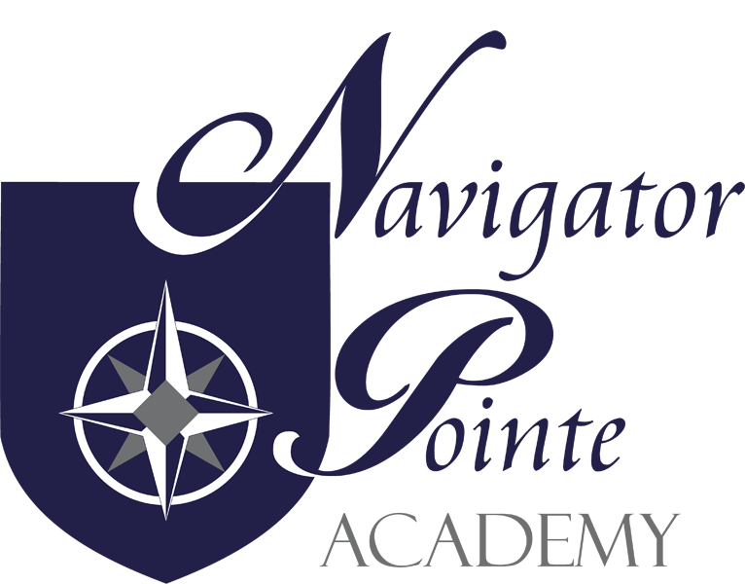

NPA TEACHER AND STUDENT SUCCESS PLAN
2025-2026

GOAL: Increase school performance and student academic achievement by two percent.

MEASURE: Common Formative Assessments (CFAs), Acadience and RISE assessments,
95% Interventions Diagnostics and Assessments, CKLA/Language Arts, and Saxon Math Assessments.

TOTAL ALLOCATION: $119,433.74

PLAN ELEMENTS:

STRATEGIES: ALLOCATION:
STRATEGY #1: Increase teacher salaries. 40% of total
ACTION: Increase teacher salaries and benefits .
MEASURE: Payroll Increases.

STRATEGY #2: Improve/maintain teacher retention. 5% of total
ACTION: Provide retention incentive for teachers.
MEASURE: Teacher retention rate.

STRATEGY #3: Increase support for students. 55% of total
social/emotional/behavior learning.
ACTION: Salary/wage for social-emotional.
learning and support/ school psychologists.

MEASURE: Utilization of SEL/Zones of Regulation
and SEL learning for all students.

