Utah Conservation Commission
Kelly Pehrson, Commissioner
Utah Department of Agriculture and Food

Meeting Notice

Date: Time:
November 4, 2025
1:00 PM—4:00 PM

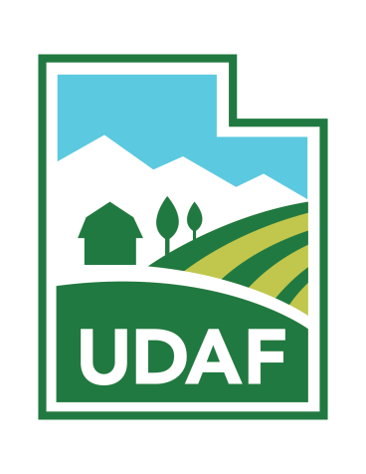
Location: Hilton Garden Inn, Ballroom E - St George Utah 1731 South Convention Center Dr
St George, Utah 84790

Join:
meet.google.com/wdc-ynmf-kbz Join by phone
(US) +1 724-740-8875 PIN: 513
914 895#
For more information contact:
Jim Bowcutt, Director Cell: 435-232-4017
Email: jdbowcutt@utah.gov

Jace Farnsworth, Deputy Director Cell: 435-222-4105
Email: jacefarnsworth@utah.gov

Cathy Christensen, UCC Executive Assistant Office: 801-982-2225
Email: cathychristensen@utah.gov

Utah Conservation Commission
Agenda
November 04, 2025

- Welcome and Introductions—5 min
Kelly Pehrson, Commissioner
- Meeting Minutes Approval—5 min (action item)
Kelly Pehrson, Commissioner

- AgVIP/Soil Health Program Update - 10 min Katie Ottmann, Soil Cons Program Manager

- Water Optimization Program Update - 10 min Brian Christensen, Water Opt. Asst. Manager

- Pollinator Program Updated - 10 min
Liz Hamilton, Pollinator Program Manager

- ARDL Staff Report— 10 min
Sarah Clancy, Loan Program Manager ARDL Report
ARDL Loan Proposals - (action item)

- UDAF Conservation District Audit - 15 min
Jace Farnsworth, Deputy Director, Conservation Division

- Schedule next quarter's (2026) meeting - 10 min Jim Bowcutt, Director, Conservation Division

- Additional Items

- Adjourn

