EA Policy 3A.06.006 Conflict Resolution Policy

Excelsior Academy believes that members of its school community; including parents, students, faculty, staff, administration, and the Board are entitled to positive experiences when involved with, learning from, teaching, and working with other members of the school community. We acknowledge that conflicts and concerns may arise from time to time. Furthermore, issues that are not dealt with directly can become destructive to the school community and are therefore detrimental to the learning process of our students. This policy is hereby adopted for the purpose of facilitating the handling of such conflicts and concerns and to provide avenues for their resolution.

It should be noted that this policy in no way intends to discourage or limit any individual’s legal responsibility to report unlawful activities as mandated by law.

STEP 1:
The Board maintains that school community members can generally resolve their concerns by working to find a solution through an open and respectful discussion between the parties involved. Community members are encouraged to work in a timely, reasonable, and cooperative manner to resolve any conflicts and concerns with the party directly involved.

Conflicts or concerns should be addressed as soon as possible, but not more than fifteen (15) working days following the date when concerned parties knew, or should have known, of the circumstances which created the conflict or concern.

Parents
A parent who has a complaint regarding a school employee should address his or her concern with the involved employee(s) in a respectful way. A parent who has a concern with another student or an issue regarding discrimination, harassment, or bullying should reach out immediately to their child's teacher.

Students
Students are encouraged to advocate for themselves in a respectful and cooperative conversation when they have concerns involving peers, faculty, and staff members. Students are always encouraged to share information about their school experience with their parents. In the case where a student needs help resolving a conflict, a student may reach out to a trusted adult who will follow the process outlined in this policy.

Staff & Faculty
An employee who has a complaint regarding another employee must first address his or her concerns with that employee in a respectful way. An employee who has a complaint regarding a parent or community member, that affects the ability of their job responsibilities, should reach out to the individual first, then to the employee’s direct supervisor if assistance is needed.

Director
An employee who has a complaint involving a director must first address his or her concerns with the director in a respectful way.

STEP 2:
If the parent, student, or employee is unable to resolve complaints following step 1, the complainant should email the direct supervisor of those involved and the Human Resources department to discuss the concern. If concerns persist, the director and/or HR will inform the School Director.

If a parent has a concern regarding the School Director, and step one has been completed, the complainant should reach out to the Board Parent Advocate following the procedures outlined in step three.

If an employee has a concern regarding the School Director, and step one has been completed, the complainant should reach out to the human resource department following the procedures outlined in step three. The HR representative should respond to any written complaints within one (1) active school day after receiving the complaint.

STEP 3: Human Resource or Board Parent Advocate Appeal
If a parent or employee complaint has not been resolved through steps 1 and 2, the complainant may then request an appeal. Unresolved complaints from parents may be appealed through the Board Parent Advocate. Unresolved complaints from employees may be appealed through HR. An appeal can be made by writing a detailed letter specifying:
- the name of the individual who is bringing the complaint forward. Anonymous complaints will not receive credence.
- all individuals involved, directly or witness to the event
- details of the events that led to the complaint, including dates and times
- details of efforts to resolve the problem, including dates and times
- a requested solution

Appeal personnel will carefully and objectively consider the appeal. They may gather additional information from the complainant, witnesses, employees, administration, or professional consultants.

Appeal personnel will consult with the School Director for any necessary action. If the complaint is about the School Director, HR and the Board Parent Advocate will consult together.

Appeal personnel are not obligated to hear a conflict or concern if the complainant has not initiated problem-solving efforts first with the individual(s) directly involved. The only exception to this is if the concern is regarding illegal workplace harassment or discrimination, health or safety violations, or any other illegal or unethical behavior regarding school administration. In this case, the complainant may write HR immediately.

Parents and staff members are welcome to address any concerns with this policy, or any school policy, during the public comment segment of monthly board meetings or in writing to the Board at any time. Written concerns should be addressed to board@eautah.org. It is important to note that issues involving personnel concerns will not be addressed in an open, public meeting of the Board.

Hotline Complaints
Excelsior Academy will respond to hotline complaints received through the Utah State Board of Education (USBE) or its local education hotline.
- Complainant Contact
If complainant contact information is available, Excelsior Academy shall promptly make at least two good faith attempts to contact the complainant. The Executive Director or designee will document:
  - the LEA personnel making contact;
  - the type of contact (e.g., phone or email);
  - the date of the contact; and
  - the resolution of the concern or action steps to be taken.
- Coordination with USBE
Excelsior Academy will cooperate with the USBE when required, ensuring compliance with all reporting and documentation requirements.

MISCELLANEOUS PROVISIONS
- No person shall suffer recrimination or discrimination because of participation in this complaint procedure.
- Employees shall be free to testify regarding any complaint filed hereunder.
- Confidentiality will be observed pending resolution of the complaint.
- A representative of his/her choice may accompany the complainant in all stages of these proceedings.
- The HR department will maintain records of all complaints submitted to HR or directors. The records will be kept in a separate and confidential file. Information regarding complaints will be classified as private.
- Gossip among school employees will not be tolerated. When employees have concerns, they should follow the procedure in this policy to resolve such concerns. Gossip may be grounds for disciplinary action, up to and including termination of employment.
- Parents may not represent a group in bringing concerns to the Excelsior Academy administration or Board of Trustees. Concerns must be brought by a parent about their own students or their own individual concerns. In order to preserve the confidentiality of our students, group concerns will not be addressed.

Board of Trustees:
The purpose of the Board is to provide the strategic vision for the school; hold the Executive Director accountable for academic success; provide financial oversight; and create policies for the operation of the school, but the Board does not manage the school on a daily basis. Rather, the Executive Director manages by implementing the policies adopted by the Board and aligns operational procedures with the vision the Board has created. As such, the Executive Director is the person to help resolve conflicts within the school.

Appendix:
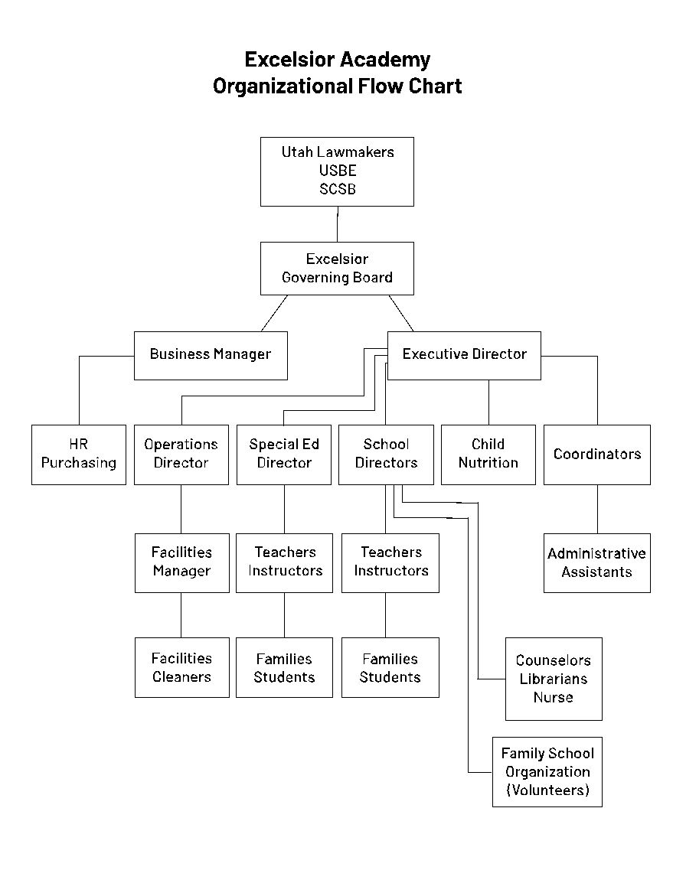Adopted: February 19, 2021
Amended: November 2021
Amended: October 2022

