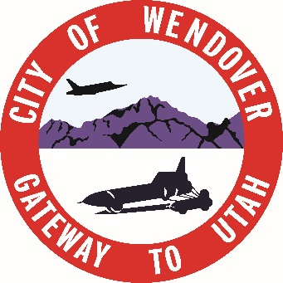
920 E Wendover Blvd
P.O Box 430
Wendover, Ut 84083
PHONE # 435-665-7771
FAX #435-665-2523

BUDGET PUBLIC HEARING 2025-2026 #1

DATE: November 5th, 2025
TIME: 6:15 PM
PLACE: WENDOVER CITY TOOELE COUNTY COMPLEX BLDG
920 EAST WENDOVER BLVD.

- Budget Augmentation 2025-2026

INCOMPLIANCE WITH THE AMERICAN WITH DISABILITIES ACT, INDIVIDUALS NEEDING SPECIAL ACCOMMODATIONS (INCLUDING AUXILIARY COMMUNICATIVE AIDS AND SERVICES) DURING THESE MEETINGS SHOULD NOTIFY LILIANA SORIANO AT THE WENDOVER TOOELE COUNTY COMPLEX AT 920 EAST WENDOVER BLVD. (435 665 7771). AT LEAST THREE DAYS PRIOR TO THE MEETING TO BE ATTENDED.

POSTED: October 23rd, 2025
- WENDOVER UTAH CITY OFFICES, WENDOVER UTAH
- WENDOVER POST OFFICE, WENDOVER UTAH
- THE WENDOVER TIMES, WENDOVER UTAH
- UTAH PUBLIC MEETING WEBSITE

THE CITY OF WENDOVER, UTAH IS AN EQUAL OPPORTUNITY PROVIDER AND EMPLOYER.

