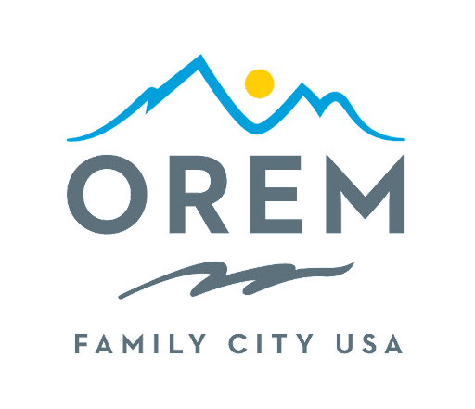
NOTICE OF GENERAL ELECTION VOTING
FOR THE CITY OF OREM
2025 MUNICIPAL GENERAL ELECTION

Candidates for Mayor (1 open seat)
Dave Young
Karen McCandless

Candidates for City Council (3 open seats)

Quinn Mecham
Crystal Muhlestein
Doyle Muhlestein
Angela Moulton
LaNae Millett
David M. Spencer

The Municipal General Election for the City of Orem is scheduled for November 4, 2025. The election will primarily be conducted through mail-in ballots. To ensure your vote is counted, make sure your ballot is received by November 4, 2025.

Mail-in ballots can be deposited in drop boxes until 8 PM on Election Day. Additionally, provisional ballot registration will be available at any vote center.

Orem Election Vote Centers – Polls are open on Tuesday, November 21 from 7 AM – 8 PM:
Center Point Church – 1550 Sandhill Road, Orem, UT 84058
Drop Boxes:
Orem – 56 N State Street, Orem, UT 84057 (Orem Library Drive Thru)
Orem – 93 N 400 E, Orem, 84097 (Behind Orem Friendship Senior Center)
For other voting and drop box locations in the county, please go to www.utahcounty.vote

Qualifications to Vote:
To qualify to vote in these elections, a person must be 18 years old on or before November 4, 2025, be a U.S. citizen, and a resident of the applicable entity for at least thirty days prior to November 21, 2025.

ADA Voting Accommodations:
ADA accommodations will be available at all Utah County voting locations on Election Day.

Election Related Information:
For other election-related details, please refer to the following sources: Utah County Elections, https://vote.utah.gov/, https://orem.gov/elections/ , visit 100 E Center Street, Suite 3100, Provo, Utah 84646, or reach out to the Utah County Elections Office at 801-851-8128.



/s/ Teresa McKitrick, City Recorder
Dated this 22nd day of November 2025
Published on the Utah Public Notice Website, the Orem website, and in the Orem City Hall

