Milford Public Library Board
Monday June 30, 2025 2:00 PM
Milford Library, 400 South 100 West
Milford, Utah 84751

Board Members Present: Library Director Cynthia Carter, Board Members: Jaynell Bailey, Sherri Yardley, Connie Puffer, Lydia Gross, Shanyce Maxwell.
Absent: Meaghan Ah-Fook, Lynae Malchus, Evelyn Wright.
Call to Order
The meeting was called to order at 2: 10 pm.

Approval of Minutes

- Approve minutes from previous meeting
MOTION: to accept minutes from previous meeting, Connie Puffer motioned, Sherri Yardley seconded. The motion carried with the following votes:
YES: Jaynell Bailey, Shanyce Maxwell, and Lydia Gross
NO: None
ABSENT: Lynae Malchus, Evelyn Wright and Meaghan Ah-Fook

Old Business

- Review of IOAP policy and corrections
MOTION: Board Member Connie Puffer moved to approve. The motion was seconded by Jaynell Bailey. The motion carried with the following votes:
Yes: Sherri Yardley, Shanyce Maxwell and Lydia Gross
No: None
ABSENT: Lynae Malchus, Evelyn Wright and Meaghan Ah-Fook

New Business

None

Policies

None

Board Comments

None

Library Staff Comments

None

Next Meeting will be held October 16, 2025 at 5:30 p.m.

Future Agenda items:

- None

Meeting Adjournment ~ as there was no further business the meeting adjourned at 2:13 PM.
APPROVED by the Board on the __16__ day of __October______, 2025

Minutes taken by: Lydia Gross

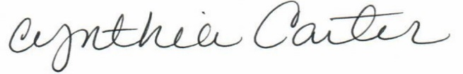
Cynthia Carter, Library Director

