CITY OF OREM
DEVELOPMENT REVIEW COMMITTEE MINUTES
October 13, 2025

The following items are detailed in these minutes:
- Centennial Acres Plat C - Plat Amendment - Located generally at 1670 North 680 West – Approved
- Raspados y Elates Alejo - Temporary Site Plan - Located generally at 516 North State Street – Approved
- Rocket Gem D - Condo Conversion - Located generally at 241 W 310 North – Approved
- Avanesyan Motors - Site Plan - Located generally at 62 E 1700 South – Approved
- Mountain Grove Plat D - Plat Amendment - Located generally at 1365 N 330 East – Approved
- Minutes from the September 29th, 2025, DRC Meeting – Approved

Place: Aspen Conference Room (Floor 2) – City Hall Building – 56 North State Street, Orem Utah, 84057

11:02 a.m. Jared Hall called the meeting to order.

Those Present: Jared Hall, Chelsea Lindsey, Chris Clements, Heath Stevenson, Aaron McKnight, Darren Pead, DRC Members; Rebecca Gourley, Associate Planner

Those Excused: Derek Spencer, Rick Sabey, Taggart Bowen, Steve Norman, Gary McGinn, DRC members; Grace Bjarnson, Associate Planner

- Centennial Acres Plat C - Plat Amendment - Located generally at 1670 North 680 West – Approved
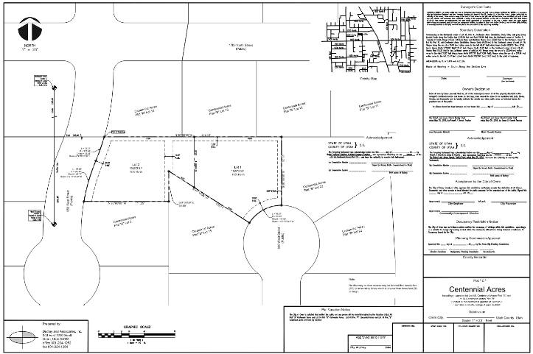
Rebecca Gourley introduced the Centennial Acres Plat C Project. The applicant, Robert Church, requested a plat amendment so that he could expand his backyard boundary line. This project is located at 1670 North 680 West in the R8 zone. The development review committee found that this amendment is compliant with code. There were no questions or comments regarding this plat.

DRC Action: Aaron McKnight motioned to approve the Centennial Acres Plat C Plat Amendment. Chelsea Lindsey seconded the motion. The motion passed unanimously.

Yes: Jared Hall, Chelsea Lindsey, Chris Clements, Heath Stevenson, Aaron McKnight, Darren Pead
No: None

- Raspados y Elotes Alejo - Temporary Site Plan - Located generally at 516 North State Street – Approved

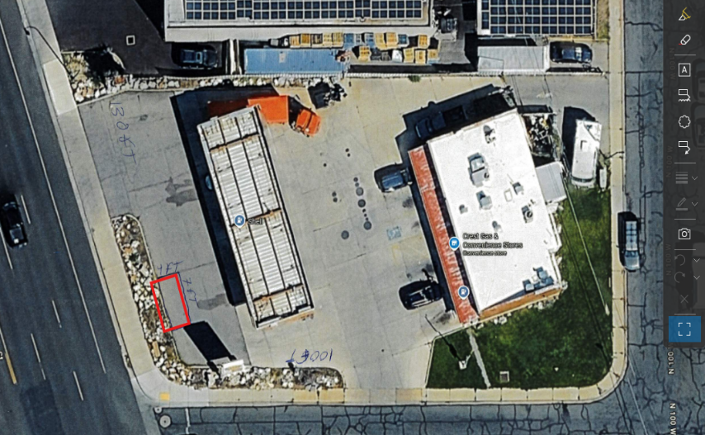
Rebecca Gourley introduced the Raspados y Elotes Alejo Temporary Site plan. The applicant, Maria Del Rosario Alejo Barrales, requested to put up a temporary food stand for the sale of fruits, vegetables, and other pre-prepared corn treats. This project is located at 516 North State Street in the C2 zone. The item was turned over to the DRC for questions.

Aaron McKnight asked staff to clarify what the difference between a temporary site plan for a fruit or vegetable stand and a transient merchant is, as transient merchants are prohibited per code 12-5-10. Jared Hall and Rebecca Gourley advised that the nature of the request for a temporary site plan is what prevents the applicant from being identified as a transient merchant, as the temporary site plan is a semi-permanent structure that stays in place, receives building inspections, and a business license. Additionally, fruit and vegetable stands are identified in code as eligible for temporary site plans and the City has a history of approving them, provided they meet code and safety requirements.

Chelsea Lindsey asked if any food would be prepared at the site, and if the site required a pre-treatment inspection. Jared Hall clarified the applicant would only be selling fruits, vegetables, and pre-prepped food, and therefore would not need a pre-treatment inspection.

No further questions or comments were raised. The development review committee found that this temporary site plan is compliant with code.

DRC Action: Chris Clements motioned to approve the Raspados y Elotes Alejo Temporary Site Plan. Chelsea Lindsey seconded the motion. The motion passed unanimously.

Yes: Jared Hall, Chelsea Lindsey, Chris Clements, Heath Stevenson, Aaron McKnight, Darren Pead
No: None

- Rocket Gem Plat D - Condominium Conversion - Located generally at 241 W 310 North – Approved

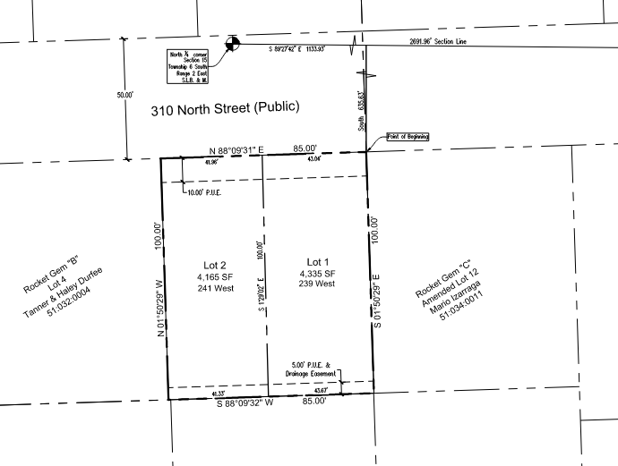
Rebecca Gourley introduced the condominium conversion of Rocket Gem Plat D. The applicant proposes to convert an existing duplex into individual ownership townhomes at 241 West 310 North in the R7.5 zone. The project includes upgrading the existing structure with a second story and front porch, which is within the legal non-conforming expansion ordinance, as it does not increase the ground footprint. Each unit will have its own utilities and tandem parking, and the property will function as a twin home with a fee title down the middle, eliminating the need for a condominium declaration but requiring shared wall agreements. The item was turned over to the DRC for questions.

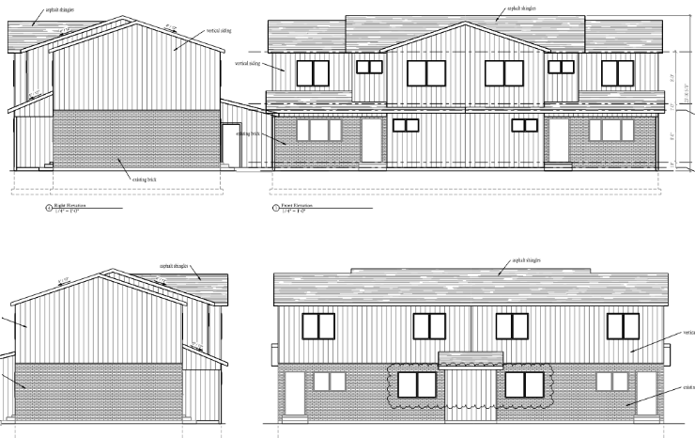
Aaron McKnight asked if the DRC was approving the subdivision itself or the site plan. Jared Hall and Rebecca Gourley advised that the DRC was approving both; The ordinance for condominium conversion for townhomes requires a fee-title split of the property, the lot subdivision, and the site plan.

Chelsea Lindsey commented that there must be an HOA or CCRs for the shared wall. Jared Hall agreed, commenting that the shared wall agreement will prevent the townhomes from being split into separate upstairs and downstairs units.

No further questions or comments were raised. The development review committee found that this condominium conversion is compliant with code.

DRC Action: Darren Pead motioned to approve the Rocket Gem Plat D Condominium Conversion. Chris Clements seconded the motion. The motion passed unanimously.

Yes: Jared Hall, Chelsea Lindsey, Chris Clements, Heath Stevenson, Aaron McKnight, Darren Pead
No: None

- Avanesyan Motors - Site Plan - Located generally at 662 E 1700 South – Approved

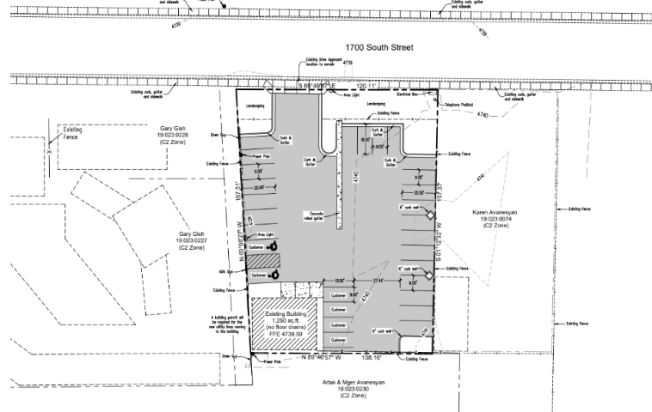
Rebecca Gourley presented the Avanesyan Motors site plan located at 662 East, 1700 South in the C2 zone. The site plan which involves improving an existing car dealership's parking and storage area. The plan includes redoing asphalt and rearranging parking while keeping the existing building unchanged. No questions or comments were raised. The development review committee found that this temporary site plan is compliant with code.

DRC Action: Chelsea Lindsey motioned to approve the Avanesyan Motors Site Plan. Chris Clements seconded the motion. The motion passed unanimously.

Yes: Jared Hall, Chelsea Lindsey, Chris Clements, Heath Stevenson, Aaron McKnight, Darren Pead
No: None

- Mountain Grove Plat D - Plat Amendment - Located generally at 1365 N 330 East – Approved

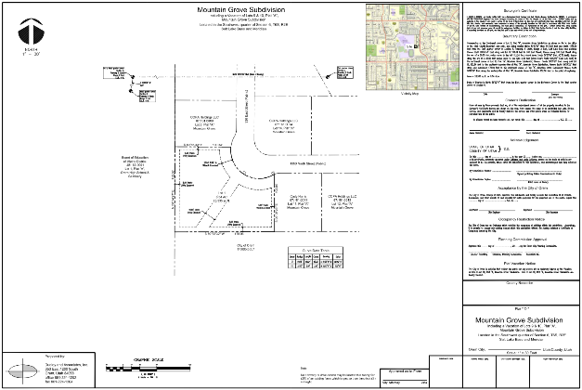
Rebecca Gourley presented the Mountain Grove Plat D Plat amendment, located generally at 1365 North 330 East. The applicant proposed combining two existing lots into one, to allow for the construction of a new accessory pool and pool house on the southeast portion of the lot. No public utility easements are to be altered.

DRC Action: Darren Pead motioned to approve the Mountain Grove Plat D plat amendment. Chelsea Lindsey seconded the motion. The motion passed unanimously.

Yes: Jared Hall, Chelsea Lindsey, Chris Clements, Heath Stevenson, Aaron McKnight, Darren Pead
No: None

- Minutes from the September 29th, 2025, DRC Meeting

The minutes for the September 29th 2025 DRC meeting were discussed. No issues were found. The DRC members moved forward with a vote.

DRC Action: Chelsea Lindsey motioned to approve the minutes. Chris Clements seconded the motion. The motion passed unanimously.
Yes: Jared Hall, Chelsea Lindsey, Chris Clements, Heath Stevenson, Aaron McKnight, Darren Pead
No: None

- Adjourn
DRC Action: Chris Clements motioned to adjourn. Darren Pead seconded the motion. The motion passed unanimously.
Yes: Jared Hall, Chelsea Lindsey, Chris Clements, Heath Stevenson, Aaron McKnight, Darren Pead
No: None

Adjourn: 11:12 a.m.
Approved On: DRAFT

