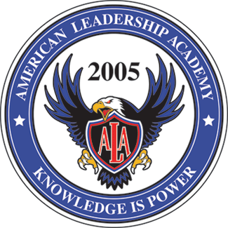

American Leadership Academy
Board of Trustees/Charter Trust Lands Council Meeting Agenda
October 22, 2025 6:00pm
ALA Junior High Upstairs room 226

Subject________________________________________________________________________
Approval of Board Minutes from 9-10-25

Director Reports:
Board Training Report - USBE Required Hotline Training
Fraud Risk Assessment

SDiediker Presents:
Title 1 Parent Engagement Policy

JDavis Presents:
Policy Salary Supplement for Highly Needed Educators (SHINE) update
TSSA Budget Update
Utah Grants Budget

JSearle Presents:
Fee Update

LNichols Presents:
Final E-Sports Approval

Open Public Discussion -

