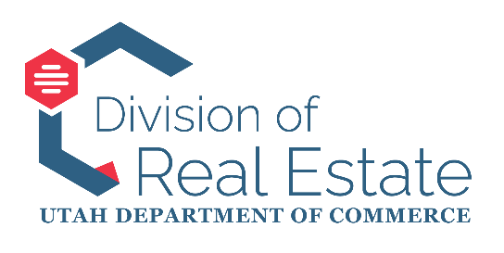

STATE OF UTAH
REAL ESTATE APPRAISER LICENSING AND CERTIFICATION BOARD
MEETING MINUTES
September 24, 2025 9:00 am

Utah Appraiser Licensing and Certification Board:
Keven Ewell, Chair
Kris Poulson, Vice Chair
Richard Sloan
Jeffrey T. Morley (Unable to attend)
Ron Jensen
Kelle Smart (Unable to attend)
(One Vacancy)
Commencement
- The September 24, 2025 meeting of the Appraiser Licensing and Certification Board commenced at approximately 9:00 am with Chair Ewell conducting.
- The meeting initiated without a quorum, proceeding with public comment and reports, but deferring motions and decisions. (There was no public comment.)
- Board Member Sloan joined, establishing a quorum, and the Board approved the minutes from August 27th.
Director’s Report
- Director Leigh Veillette announced that Dallas Thomas, the former administrative assistant, is no longer with the division, and she will serve as the primary contact for board-related matters until a new administrative assistant is hired.
- Ms. Veillette also mentioned upcoming structural and aesthetic changes to the real estate website (realestate.utah.gov) as part of a statewide initiative.
- Ms. Veillette confirmed that the division now has control of the board’s website, allowing for direct updates to open seat applications and streamlining the process for new board members.
- Ms. Veillette reported on the Appraisal Subcommittee’s (ASC’s) appraiser report, highlighting an audit of 487 appraiser education courses by Appraisal and Mortgage Operations Supervisor Michael Genco.
  - Nine courses were found non-compliant with AQB criteria and removed, and 23 courses required additional documentation within 30 days.
  - The ASC found these efforts sufficient, precluding an off-cycle review, with compliance to be monitored during the 2026 review (scheduled for June 23rd-25th, 2026).
- Ms. Veillette outlined upcoming hearings and board meeting schedules. The Board’s schedule for all of 2026 has been planned, and invitations will be sent soon to all current members.
Licensing and Education Report
- Licensing and Education Manager Laurel North provided an update on the division’s annual Instructor Development Workshop, scheduled for October 23rd at the Double Tree Hotel.
- Applicant exam statuses: one licensed appraiser and one certified general approved; one licensed appraiser and one certified residential exam denied.
- Ms. North noted an increase of 11 appraiser trainees.
- Mr. Genco and Appraisal and Mortgage Enforcement Supervisor Bryn Kaelin will attend the Appraisal Summit and report back at the October Board meeting.
Board and Industry Issues
- Hearing Officer and Records Manager Justin Barney informed the Board about an upcoming Association of Appraiser Regulatory Officials (AARO) conference in Atlanta (October 6th-8th), which division representatives will attend.
- Mr. Barney noted ongoing efforts to update real estate administrative rules, with the most recent appraisal rule amendment occurring earlier this year.
Enforcement Report
- Chief of Enforcement Kadee Wright provided August enforcement statistics: no new complaints, five closed cases, 33 open investigations, and 14 cases pending legal action.
- Ms. Wright reiterated the ongoing need for mentors for the mentorship program and announced an informal enforcement hearing scheduled for November 18th.
Caden Hickman’s Appraisal Review
- The Board discussed Caden Hickman’s submitted appraisal, which was continued from a previous meeting.
- It was noted that the appraisal was not on the current meeting’s agenda, preventing action.
- Chair Ewell requested it be added to the October agenda for review.
Adjournment
- A motion was made and seconded to adjourn the meeting.
- The motion passed unanimously.
Meeting Adjourned.

