CLINTON CITY PUBLIC NOTICE
NOTICE OF CITY COUNCIL VACANCY

Notice is hereby given that a vacancy has occurred on the Clinton City Council following the resignation of a Councilmember. The unexpired term runs through December 31, 2027.
In compliance with Utah Code § 20A-1-510, the Clinton City Council will fill this vacancy by appointment at a public meeting. All interested persons are invited to apply and participate in the process.
Public Meeting to Appoint
- Date: Tuesday, November 18, 2025
- Time: 6:00 p.m.
- Location: Clinton City Hall, 2267 North 1500 West, Clinton, Utah
Qualifications
To be considered for appointment, an individual must:
- Be a United States citizen.
- Be a registered voter within Clinton City.
- Have resided within Clinton City for at least 12 consecutive months immediately preceding the appointment.
- Currently reside within Clinton City boundaries.
- Not be disqualified by statute (e.g., felony conviction or other legal incapacity under election law).
How to Apply
Submit a letter of interest, résumé, and completed Conflict of Interest Disclosure Form to:
Lisa Titensor, City Recorder
Clinton City Hall
2267 North 1500 West
Clinton, UT 84015
or via email: ltitensor@clinton.utah.gov
Deadline for submission: Monday, November 10, 2025, by 5:00 p.m.
Interview & Selection Process
To be considered for appointment, all applicants must participate in a public interview during a special City Council meeting on Tuesday, November 18, 2025, either in person or virtually.
Conflict of Interest Disclosure
Pursuant to Utah Code § 20A-1-510(8), each applicant must complete a Conflict of Interest Disclosure Statement under § 10-3-301.5 and submit it with their application. The City will post each disclosure on its website within two business days of receipt and maintain it for at least ten days after the appointment.
Posting & Notice
This notice will be posted on the Utah Public Notice Website, the Clinton City website, and at Clinton City Hall in accordance with § 20A-1-510.
For additional information, contact:
Lisa Titensor, City Recorder
Phone: (801) 614-0700
Email: ltitensor@clinton.utah.gov

Dated this 15th day of October, 2025.
________________________________________
Lisa Titensor, Clinton City Recorder
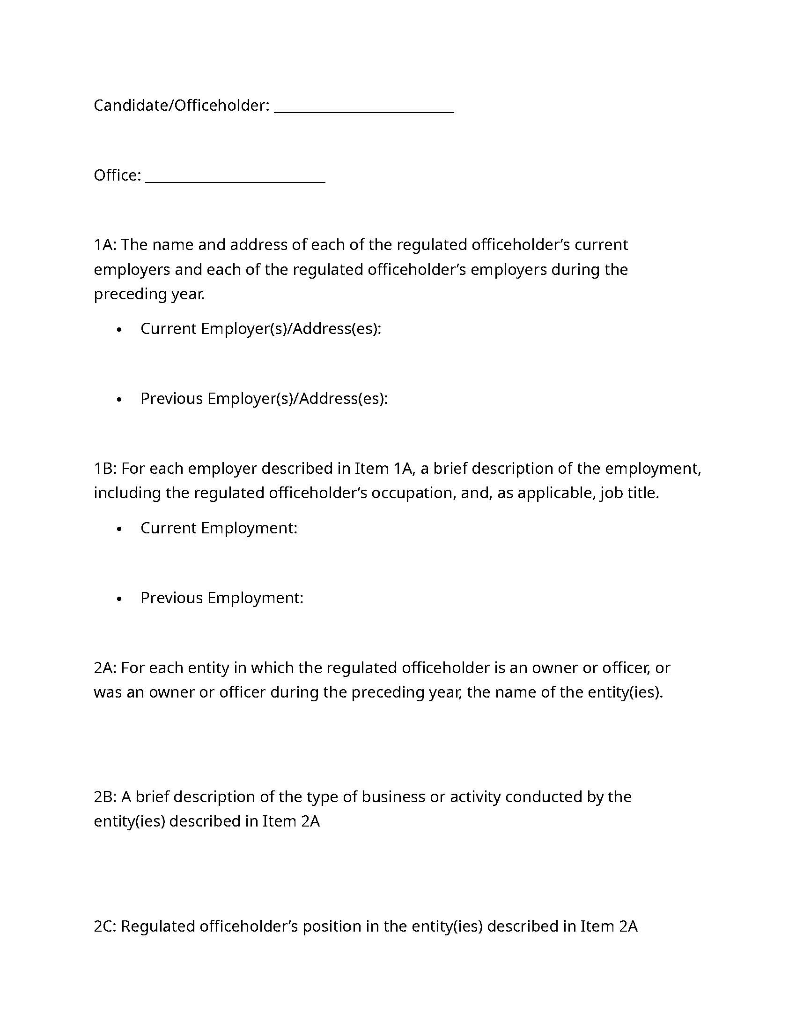
CONFLICT OF INTEREST FORM Utah State Code § 20A‑1‑510(8)

