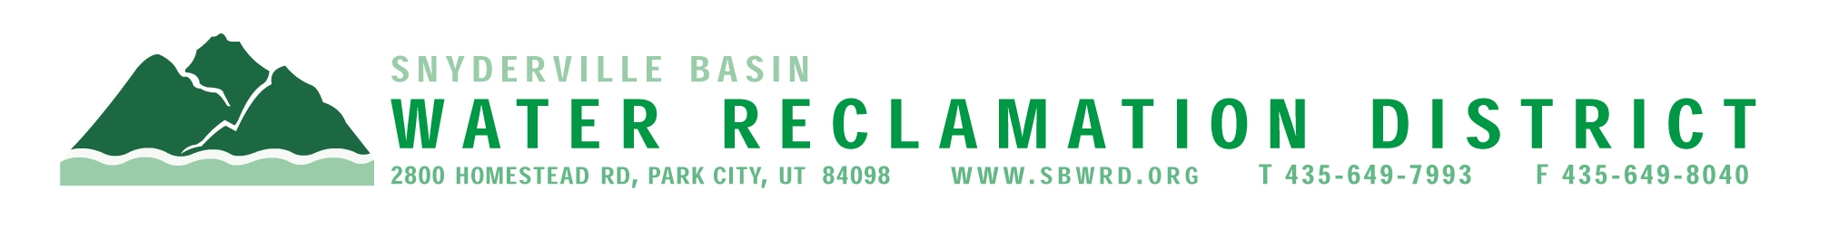
BOARD OF TRUSTEES MEETING

AGENDA

October 20, 2025
** District Office**
5:00 p.m.

** The meeting is open to the public and will also be
conducted electronically using Microsoft Teams**

** For information on how to connect to the meeting, please call 435.649.7993 or email
Dan Olson @ dolson@sbwrd.org by 4:30 p.m. on Monday, October 20, 2025**

I. CALL TO ORDER

II. CONSENT AGENDA
- Approval of Board Meeting Minutes for September 24, 2025
- Escrow Fund Reduction Approval: Prospector Square Lot E – Retain 0%
- Final Project Approval: FJ Gillmor Subdivision

III. PUBLIC INPUT

IV. APPROVAL OF EXPENDITURES – Bills in the Amount of $1,404,517.47

V. SUBDIVISION PROJECTS
Estimated LEA REs Year to Date: # Above Splitter 1.3; # ECWRF 23.33; # SCWRF 43; Total 67.33
Proposed this Meeting: # Above Splitter 0; # ECWRF 0; # SCWRF 0; Total 0

VI. DISTRICT MANAGER
- Discussion Items – Review 2026 Tentative Budget
- Information Items
- Utah Safety Council Awards – Award of Merit & Perfect Record
- Financial Statement
- Impact Fee Report

VII. FUTURE AGENDA ITEMS
- Projects
- Operations
- Finance
- Governmental Matters

VIII. ADJOURN

If you are planning to attend this public meeting and, due to a disability, require reasonable accommodation in understanding, participating in or attending the meeting, please notify the District twenty-four or more hours in advance of the meeting, and we will try to provide whatever assistance may be required. Board members may appear telephonically.

