

October 14, 2025

RE: Notice of Approved Boundary Action

To Whom it May Concern:

This is to inform you that an unincorporated area in Utah County, has recently been annexed into the City of Santaquin. Please see the attached copy of the Certificate of Annexation and map for the Cemetery II Annexation.

Please let me know if you have any questions.

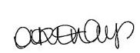
Sincerely,

Amalie R. Ottley
Recorder
Santaquin City
(801)754-1904
aottley@santaquin.gov

