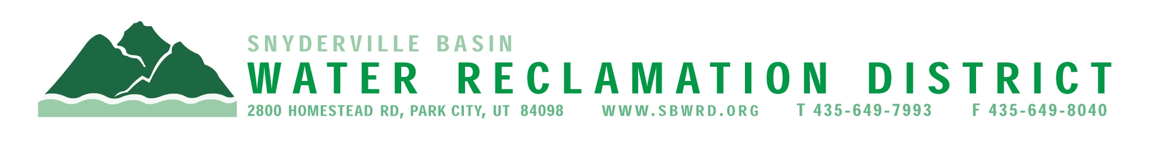

NOTICE OF 2025 ELECTION CANCELLATION

In accordance with Utah Code Ann. § 20A-1-206,
the Snyderville Basin Water Reclamation
District has cancelled the election scheduled
for November 4, 2025.
Jan Wilking and Mary Ann Pack were unopposed
and therefore, elected to fill the two board seats.

