Monthly Fire District Report EMS

Transports for the Year
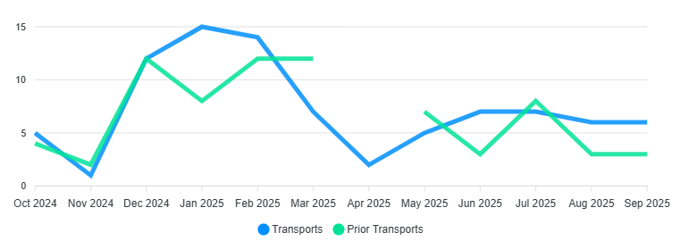

Billing

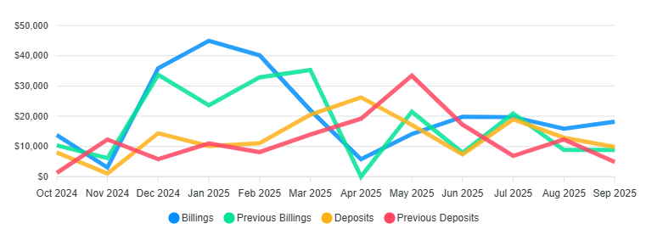

2025
Transports 69 / Billed $200,425.59 / Collected $137,363.81 / YTD

2024 Totals
Transports 74 / Billed $212,292.64 / Collected $150,340.23 /2024

Monthly Calls for Service

NFFD Trends

3 Year Monthly Call Average /22 26 Calls , Calls year to date 265

Wildland Revenue/Info 2025
Gross

