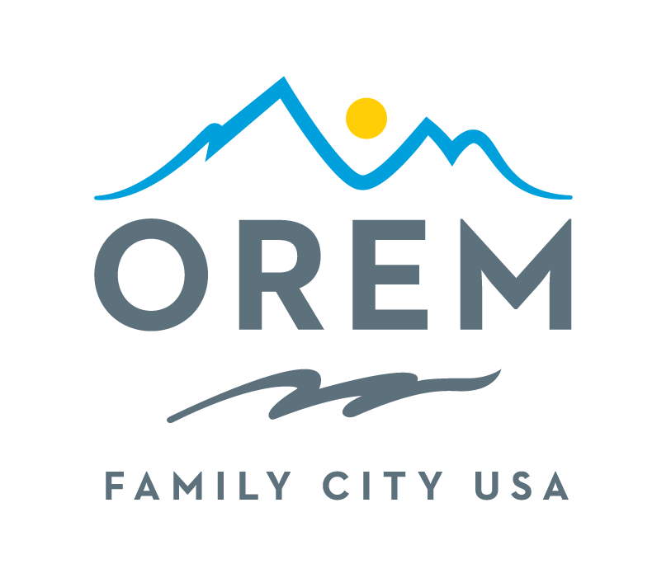
CITY OF OREM
ADVISORY BOARD/COMMISSION
MEETING AGENDA

This meeting may be held electronically to allow a board/commission member to participate.
PUBLIC BODY: Natural Resources Advisory Commission (NRAC)
DATE: 10/02/2025 ROOM: Public Works Conference Room 2
TIME: 5:00 PM ADDRESS: City of Orem Public Works, 1450 W 550 N, Orem

AGENDA ITEMS:

1. Welcome to any visitors and guests

2. Guest: Traffic Operations / Active Transport

3. Invitations for future guests – Water in November

4. Debrief Orem Family Health Festival

5. Polo & T-shirts

6. Future activities?

7. Continue conversation about trees and tree cover – Darren Hawkins

8. Other items of business

9. Review and approval of Sep 4, 2025, meeting minutes

10. Adjournment

THE PUBLIC IS INVITED TO PARTICIPATE IN ALL CITY MEETINGS.

If you need special accommodation to participate in Advisory Commission meetings
please contact us on the City's website at orem.org or call (801) 229-7000 at least 3 working days
prior to the meeting. This agenda is available on the Utah Public Notice website at utah.gov/pmn.

