DRAFT PEACE OFFICER MERIT COMMISSION
MINUTES
Thursday August 7th, 2025

MEMBERS PRESENT: David Salazar, Chair
Martha Stonebrook – Vice Chair
Chris Bertram – Member

MEMBER EXCUSED: None

OTHERS PRESENT: Carita Lucey Merit Administrator
Lieutenant Scott Laughlin, Merit Coordinator
Sergeant Michael Russell, Merit Coordinator
Amber Arnold, Merit Coordinator

David Salazar -called the meeting to order at 4:09 PM. at the Salt Lake County Government Center, Room S2-830. This meeting was also available via-Webex.

Chris Bertram- moved to approve February 5th, 2025, meeting minutes. Martha Stonebrook seconded the motion, minutes were approved by all members present.

Public comment- none

Chris Bertram- moved to approve June 11th, 2025, minutes. Martha Stonebrrok seconded the motion, minutes were approved by all members present.

Public comment- none

Carita Lucey- presented the Law Enforcement Bureau sergeant promotional exam plan. Minimum qualifications for this testing process are the same that have been used in past exam plans. Must have a minimum of five-year service time within his or her category in the Sheriff’s Office or UPD if hired by July 1st, 2024. Candidate must have a bachelor’s degree; however, service time can be substituted for the required education on a time equivalency basis. Reviewed and discussed competencies. Written policy test will be graded in the overall scoring of the testing, candidates will not need a score of 70% or above to move onto the next phase due to the small candidate pool the LEB has.

Chris Bertram- asked if the verbiage be changed from test to examination plan. Also stated that 2 more competences were added and he received a phone call, and they stated that 30 days wasn’t enough time to prepare for a policy test given the new bureau, and most people study for a year in preparation.

Jason Ackerman- explained how the Law Enforcement Bureau can access all policies related to the exam plan.
Mike Russell- is verifying the dates listed for the policy test in the draft examination plan, seems to have been an error on the dates listed.

Public comment- none

David Salazar- Close public comment and table the topic until the dates have been confirmed.

Carita Lucey- presented the Corrections & Public Safety lateral recruitment plan. New guidelines to reflect Utah POST standards, must be a US citizen or a lawful permanent resident for the last 5 years. Adding preference points to those working for the Sheriff’s Office as a part-time or sworn volunteer at a rate of two and one-half. Clarified how an applicant would receive credit for other public safety agencies that are hired from a different category.

Chris Bertram- commented on the removal of federal probation officers, would recommend that it be included to reflect different applicants from out of state. Also asked regarding the number of hours for part-time employees who must work to receive the two- and one-half credit.

Public comment- Aaron Torres would state that it still references protective service officers and needs to be changed to public safety deputies.

Matt Thompson- Would like to add the NPOST score back in, not a requirement but that they have taken it.

Carita Lucey- States that NPOST is more for the entry level recruitment and not lateral. Clarified that the positions that we have listed are examples and not necessarily limited to that. Those receiving credit would be those positions that held a LEO or SFO certifications during their employment.

Commissioners’ motion to approve the Corrections and Public Safety lateral recruitment plan. Plan approved by all members present.

Sgt Mike Russell- Confirming dates for 2025 Law Enforcement Bureau exam plan dates. With the concerns of the commission with lack of time for applicants to review policy for the upcoming sergeant’s exam plan dates for the testing will be as follows, phase one written policy test to take place September 29th, 2025, and phases II & III will take place October 6th- 8th, 2025. Dates of opening and closing will remain the same to allow more time for policy review prior to testing.

Commissioners motion to approve the 2025 Law Enforcement Sergeant exam plan. Plan approved by all members present.

Carita Lucey- presented policy 4400, talks about the merit commission will adopt a classification plan for all deputies and will approve new position classifications into the classification plan. With the addition of the law enforcement bureau, we have added those positions into the classification plan. This is only for merit positions that the merit commission has classified. The pay plans are governed by the Salt Lake County Council, whereas the position classifications are governed by the merit commission. Clarfies to the board that pay grades may change with budget seasons. This is just to add the Law Enforcement Bureau.

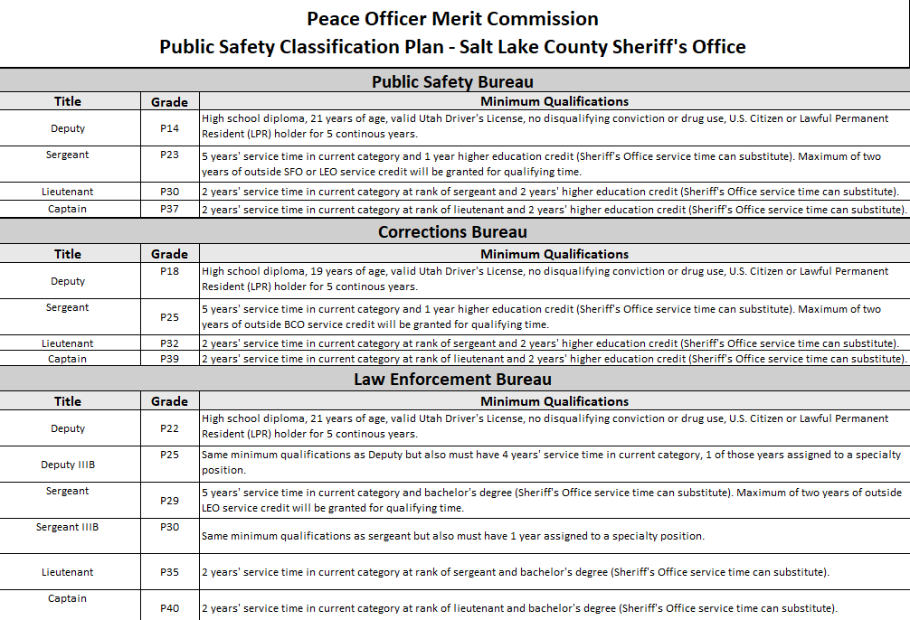

Public comment- Matt Thompson stated that there were significant steps taken years ago to remove all reference to compensation because they were not seen under the merit commission. Does not want to see it get brought up to county council to have them say we can’t change that because the merit commission hasn’t approved the change of the pay grade. Would like language to clarify that the merit commission defers to the county council for any regards to compensation.

Martha Stonebrook- could we add an asterisk after each grade?

Carita Lucey- Commission reviews classifications and County HR conducts market reviews and manages the grades, that is not a Sheriff’s Office HR function and believes everyone is familiar with the process. Notes this is not something that is made public.

Matt Thompson- would like something added to the policy that states that the merit commission is not responsible for the fiscal decision of what the actual grades are.

Ryan Scothern- can asterisk be added on the sheet referring to the Public Safety Classification Plan and policy 4400 to cover bases.

Carita Lucey- will add requested verbiage on final draft for signature for approval.

Commissioners motion to approve the Public Safety Classification Plan. Plan approved by all members present.

Sheriff Rivera- Happy to see so much engagement in this meeting and wants to thank everyone for their time.

Carita Lucey- presented 4910 administrative review policy, technical changes by removing UPD, adding language to ensure Utah Open Meetings Act is followed when conducting Administrative Reviews as prior language was confusing. This language ensures there is no misinterpretation of policy.

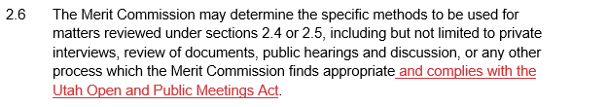

Public Comment- Chief Huth supports this change

Commissioners’ motion to approve the Merit Commission policy 4910. Policy approved by all members present.

Carita Lucey- present policy 4400 technical changes by removing UPD and changing verbiage from officer to deputy. Classification was removed in the event a new position is created it will become part of the classification plan. Removal of career ladder as we no longer have career ladders and what it is referring to is the public safety pay plan. Clarification on outside service credit is not counted towards, nor does it affect the service date, higher date or merit date.

Qualifying experience is defined as follows:

  - Equivalent, full time, paid peace officer position requiring either LEO (Law Enforcement Officer), BCO (Basic Corrections Officer) or SFO (Special Function Officer) certification with any municipal, county, federal or state law enforcement agency such as a police officer, correctional officer, deputy sheriff, constable, highway patrol trooper, or federal agent.

We have looked into other agencies, and they are giving 1:1 credit for SFO, BCO or LEO experience even if you are applying for a different category. This is to be competitive.

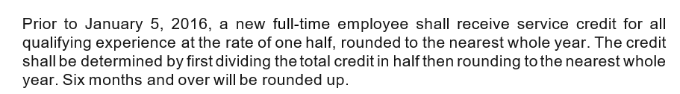

David Salazar- Would like clarification on this policy. Does this mean that if someone has experience prior to January 5th, 2016, that would only be counted as half, but anything after that would be full credit?

Chris Bertram- has concern about this, which could cause pay inequity. States that if someone is hired with 10 years’ experience as a correction officer and gets hired as a law enforcement officer and got none of that towards pay. If they are BCO certified and put themselves through the police academy and get hired you’re going to give them all that credit as if they were a law enforcement officer.

Scott Laughlin- states that the law enforcement and public safety aren’t changing. States that is how the policy is written for them. Deputies can go to West Valley and get one for one credit. The only thing changing is making it so a public safety deputy could come to corrections and get the one for one.

Chris Bertram- if someone was hired from corrections for LEO were they given credit for pay in the LEO position? If someone was hired in 2020 when we split UPD and prior to that they worked in the jail for 5 years and hot hired with UPD they didn’t get credit towards their pay.

Carita Lucey- The reason this was brought to our attention was UPD, some of the chiefs that came from there were saying that the merit commission approved that and that’s why they do it. If a corrections deputy his hired with UPD they get one for one credit. If an SFO applied with UPD they would get one for one credit. Would like to look into this with UPD and check their policy and table this for a follow up meeting.

Chris Bertram- believes this is the case, and that this may not be an issue. Would just like to make sure that we aren’t causing pay inequities.

Martha Stonebrook- would like some corrections with verbiage. Should state shall instead of received.

David Salazar- Giving one for one credit is going in the right path. Suggest that if we are going to make a change it be prospective. This would mean looking at current members who may now qualify for additional service credit but the additional pay would be moving forward and not retroactively.

The requested policy revision will be tabled as Carita is going to research the concerns and bring it back to the Commission at a later date.

Matt Thompson- on 4400 we have had this twice in the Sheriff’s Office once in 2007 and 2016 where they offered a different level of service credit separated from the office for 1 day paid out everything and then brought them back at the new rate.

David Salazar stated he did not think this sounded ideal as large numbers of staff may need to be separated but supported looking at all options.

Commissioners move to close the meeting. All approve.

Reviewed and Approved by ________________________ DATE:____________
David Salazar, Chair
Salt Lake County
Peace Officer Merit Commission

