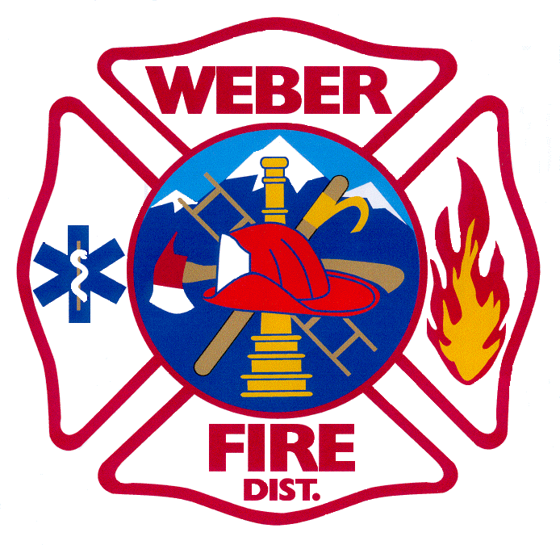
WEBER FIRE DISTRICT
BOARD OF TRUSTEES MEETING MINUTES
SEPTEMBER 23, 2025

Board Members in Attendance:
Kevin Ward, Chair | Y | Michael Hancock, Vice Chair | Y | Boyd Ferrin, Treasurer | N
Gordon Cutler | Y | Val Heiner | Y | Ryan Hill | N
Jim Truett | N | Scott Van Leeuwen | Y | Rob Vanderwood | Y
David Yonan | Y

Administration Members in Attendance:
Britt Clark, Chief | Y | Jared Taylor, Deputy Chief | N | David Reed, Deputy Chief | Y
Cody Draheim, Div. Chief | N | ‘Andrea Fiske, FSM/Clerk | Y | Jolene Whipple, Office Mgr. | Y
Amy Hugie, Attorney | N

Weber Fire District Board of Trustees - Meeting Agenda:
- Call to Order – Kevin at 6:00
- Pledge of Allegiance – Gordon
- Invocation – Val
- Public Hearing for the Impact Fee Rates per IFFP and IFA
  - Motion to open the public hearing by Val
  - Second by Scott
    - No public comments.
  - Motion to close the public hearing made by Mike
  - Second by Rob
- Discussion and action on Resolution 16-2025 - A Resolution Fixing and Prescribing a Policy for Impact Fees for Public Safety Facilities; Adopting an Impact Fee Facilities Plan for the Provision of said Facilities, Establishing a Service Area for Purposes of Equitable Distribution of Public Safety Impact Fees and Other Related Matters – Presentation by Fred Philpot
  - Discussion about the fee and how it relates to other entities and if the rate should be approved as proposed.
  - Motion to approve the rates as presented - $704 for residential; $882/1,000 sq. ft. for non-residential – made by Mike
  - Second by Scott
Roll Call Vote:
Kevin Ward, Chair | Y | Michael Hancock, Vice Chair | Y | Boyd Ferrin, Treasurer | -
Gordon Cutler | Y | Val Heiner | Y | Ryan Hill | -
Jim Truett | - | Scott Van Leeuwen | Y | Rob Vanderwood | Y
David Yonan | Y
- Adjournment
  - Motion to adjourn by Mike
  - Second by Scott
  - Adjourned at 6:20
The next Regular Meeting is Tuesday, October 14th, 2025, at 5:30 p.m.

Kevin Ward, Chair Boyd Ferrin, Treasurer

