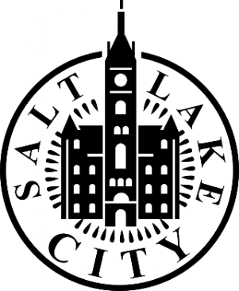

Accessibility and Disability Commission
Salt Lake City, Utah
Regular Meeting Agenda
September 25, 2025
3:00 p.m.
This meeting is a discussion among Commissioners and designated presenters.
Members of the public are welcome to attend. Please note that agenda items may be moved or discussed at different times during the meeting, depending on speaker availability and other circumstances.
Meeting Format
This will be a hybrid meeting. Attendees may join:
- In person at:
Salt Lake City & County Building
451 South State Street
Cannon Room 326
- Virtually via Zoom:
https://us06web.zoom.us/j/85729232643?pwd=kbYFQkX4jvN0kYi10Ismv9Bo05ul3I.1
Public Meeting Rules
The Commission is committed to creating a respectful and inclusive environment where everyone feels safe participating in their government. Meetings should be conducted in an orderly, efficient, and dignified manner free from disruption, intimidation, or safety concerns.
To help maintain this environment:
- Disruptive behavior or comments will not be permitted.
- Threats or intimidation toward participants will result in removal from the meeting.
- All participants are expected to treat one another with respect and courtesy.
AGENDA
- Welcome
Role Call
- Public Comment (Limited to 15 minutes)
  - Members of the public may provide comments related to the Commission’s work. Comments will be limited to two minutes of time.
- Approval of Minutes
  - Review and approval of minutes from January 2025 Commission meeting.
- Meet & Greet Follow-up (~5 minutes)
Workshop Events Sharing (Newsletters)
Identifying Series of ADA trainings for internal staff
Connecting with Utah State Fair committee
Commissioner Compensation
2026 Goals
- Parks & Public Lands Update (~15 minutes)
Capital Improvement Projects (CIP) Parks and Public Lands Update
Presenters:
Tom Millar
Katherine Andre
- A.C.E (Arts, Culture, Education Application) (~10 minutes)
A.C.E Grant Application overview
Presenter:
Katherine (Katie) Schnell
- City Updates (~20 minutes)
Led by: Angela Haylock, ADA Manager
Emergency Preparedness Manual
SEG Meeting with Amy Carmen
Accessibility Website for Elevator and Street Closures
Human Rights Day Wednesday, December 10, 2025
Next Meeting: Thursday, November 13, 2025

TENTATIVE – Closed Session
The Commission may consider a motion to enter a Closed Session in accordance with Utah Code § 52-4-205. A closed meeting may be held for purposes such as:
- a. Discussing the character, professional competence, or health of an individual
- b. Strategy sessions regarding pending or imminent litigation
- c. Discussions related to security personnel, devices, or systems
- d. Investigative proceedings regarding criminal misconduct
- Any other purpose permitted under the Utah Open and Public Meetings Act

Certificate of Posting
I, the undersigned, duly appointed ADA Manager, hereby certify that the above notice and agenda was:
- Posted on the Utah Public Notice Website in accordance with Utah Code § 63F-1-701; and
- Posted at the physical location where this meeting will be held.
Angela Haylock
Salt Lake City Mayor’s Office

Reasonable Accommodation Notice
People with disabilities may request reasonable accommodation such as alternate formats, sign language interpreters, or other auxiliary aids and services. Please make requests at least two business days in advance.
To request accommodations, contact:
Email: ADA@slc.gov
Phone: 801-535-6235
Relay: 711

Presentation Slide decks:
ACE Grant
Parks & Lands
2025 Commissioner Goals

