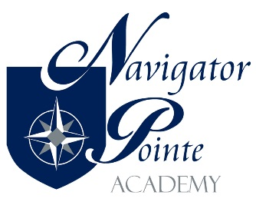

DISPUTE RESOLUTION POLICY - DRAFT

Disagreements should be solved whenever possible among the people most closely involved while preserving positive relationships. Therefore, when parents, community members, or staff members have complaints or disagreements with any parties at Navigator Pointe Academy, they should observe the following guidelines:

1. If the complaint involves a situation in the classroom, parents should seek to resolve the issue with the classroom teacher as is appropriate.

2. If a resolution with the classroom faculty is not possible, or if the complaint is with a school-wide policy or procedure, the parent or staff member should seek to resolve the issue with the Director.

3. If resolution is not possible with any of the parties above, parents or staff members should address a complaint to the Governing Board as follows:
a. Complaints should be made in writing. This allows all parties involved to work from a consistent body of information. Complaints can be emailed to governors@npacademy.org.
b. The Governing Board, in general, will not address a complaint based on hearsay or made on behalf of another staff member, parent, or family.
c. The Governing Board, in general, will not address a complaint if resolution with the appropriate individuals in Items 1, 2, or 3 has not yet been attempted in good faith.
d. The Governing Board reserves the right not to address a complaint that is made anonymously.
e. The Governing Board, in general, will not address specific complaints about the performance of individual school employees in a public meeting. If such a complaint is brought at a public meeting, the Board will take the complaint under advisement and will provide an appropriate response at a later time.
f. The Governing Board reserves the right to notify individual school employees about complaints brought against them. Parents may request that they are not personally identified as the party bringing the complaint.
g. The Governing Board will discuss said grievance in closed session and respond to said complaint via a written letter. This will occur within 30 days of receiving said grievance.

4. If a parent complaint is not addressed to the satisfaction of the people involved, parents have the right to seek resolution through the school’s authorizer.

5. This Grievance Policy is not designed to supersede or supplant federal law and parent rights under The Individuals with Disabilities Education Improvement Act of 2004 and the Family Educational Rights and Privacy Act (FERPA) as amended, 1996.

Utah Code Ann. §§ 62A-4a-410 - Immunity from Liability

Admin/Admin/200 (Policy & Procedure)/Conduct and Discipline Policy/07172017JE

