DRAFT CITY OF OREM
DEVELOPMENT REVIEW COMMITTEE MINUTES
September 15, 2025

The following items are detailed in these minutes:
- Preliminary Plat – Okolowitz Plat C – Located generally at 1274 North 260 West – Approved
- Plat Amendment – D Anna B Subdivision Plat D – Located generally at 572 South 880 West – Approved
- Final Plat – Canyon Park Plat A – Located generally at 1203 North 630 East – Continued

Place: Aspen Conference Room (Floor 2) – City Hall Building – 56 North State Street, Orem Utah, 84057

11:00 a.m. Jared Hall called the meeting to order.

Those Present: Jared Hall, Steve Norman, Chelsea Lindsey, Chris Celements, Aaron McKnight, Mark Kilmer – DRC members, Rebecca Gourley, Grace Bjarnson – Associate Planners

Those Excused: Taggart Bowen, Derek Spencer, Darren Pead, Rick Sabey, Gary McGinn

- Preliminary Plat – Okolowitz Plat C – Located generally at 1274 North 260 West – Approved
Grace Bjarnson introduced the preliminary plat for Okolowitz Plat C. This project consists of three flag lots and one interior lot, located generally at 1274 North 60 West in the C2 and R8 zones. The preliminary plat meets all code requirements. The Development Review Committee recommended the administrative site plan for approval.

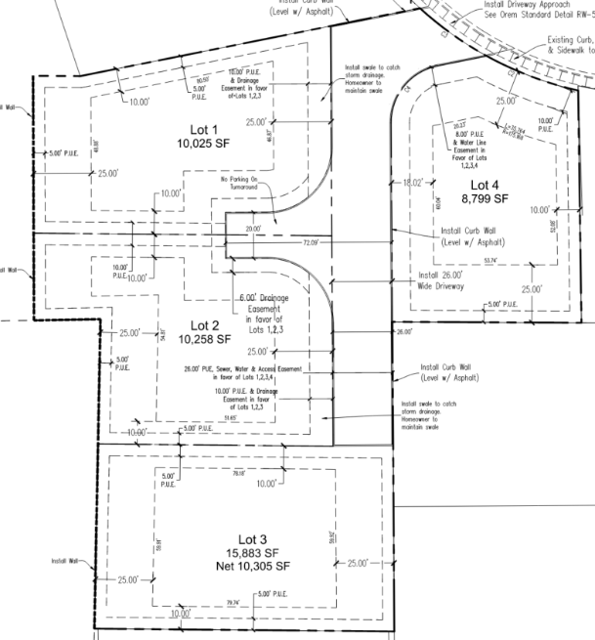

DRC Action: Steve Norman moved to approve the Okolowitz Plat C Preliminary Plat. Mark Kilmer seconded the motion. The motion passed unanimously.
Yes: Jared Hall, Steve Norman, Chelsea Lindsey, Chris Celements, Aaron McKnight, Mark Kilmer
No: None

- Plat Amendment – D Anna B Subdivision Plat D – Located generally at 572 South 880 West – Approved
Grace Bjarnson introduced the plat amendment for D Anna B Subdivision Plat D. The applicant proposed to amend the property line between Lot 1 and Lot 2, and pro
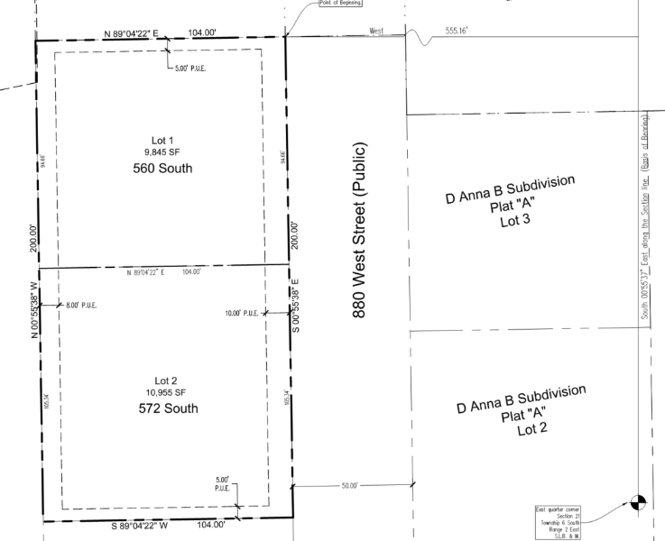
DRC Action: Chris Clements moved to approve the D Anna B Subdivision Plat D Plat Amendment. Steve Norman seconded the motion. The motion passed unanimously.
Yes: Jared Hall, Steve Norman, Chelsea Lindsey, Chris Celements, Aaron McKnight, Mark Kilmer
No: None

- Final Plat – Canyon Park Plat A – Located generally at 1203 North 630 East – Continued
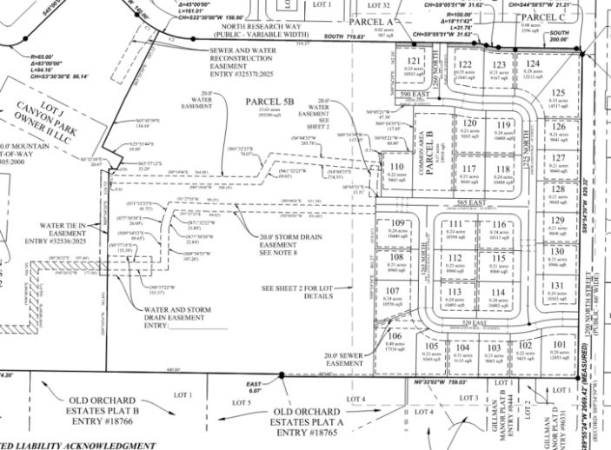
Grace Bjarnson introduced the final plat for Canyon Park Plat A. The final plat would create 31 lots located generally at 1203 North 630 East in the R8 zone. Planning staff recommended the final plat be continued to an unspecified date, as the plat had outstanding corrections to be made.

DRC Action: Aaron McKnight moved to continue the review of the Canyon Park Plat A Final Plat. Chelsea Lindsey seconded the motion. The motion passed unanimously.
Yes: Jared Hall, Steve Norman, Chelsea Lindsey, Chris Celements, Aaron McKnight, Mark Kilmer
No: None

- Minutes
The minutes for the September 2, 2025, meeting were discussed. No issues were found. The DRC members moved forward with a vote.

DRC Action: Steve Norman moved to approve the September 2, 2025, DRC minutes. Chelsea Lindsey seconded the motion. The motion passed unanimously.
Yes: Jared Hall, Steve Norman, Chelsea Lindsey, Chris Celements, Aaron McKnight, Mark Kilmer
No: None

- Adjourn
The DRC members moved to adjourn

DRC Action: Chris Clements moved to adjourn. Chelsea Lindsey seconded the motion. The motion passed unanimously.
Yes: Jared Hall, Steve Norman, Chelsea Lindsey, Chris Celements, Aaron McKnight, Mark Kilmer

Adjourn: 11:05 a.m.
Approved On: draft

