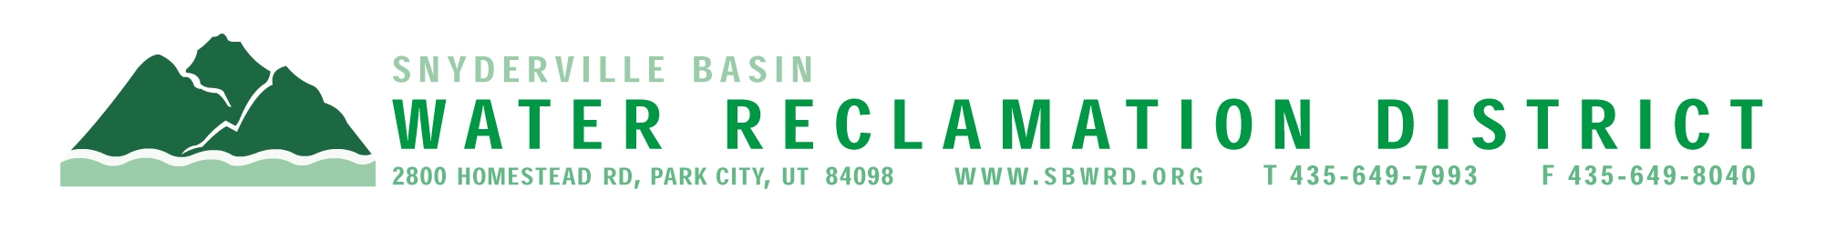
BOARD OF TRUSTEES WORKSHOP

September 24, 2025
**East Canyon Water Reclamation Facility**
2:30 p.m. – 4:00 p.m.

BOARD OF TRUSTEES MEETING

AGENDA

September 24, 2025
**East Canyon Water Reclamation Facility**
5:00 p.m.

** The meeting is open to the public and will also be
conducted electronically using Microsoft Teams**

** For information on how to connect to the meeting, please call 435.649.7993 or email
Dan Olson @ dolson@sbwrd.org by 4:30 p.m. on Wednesday, September 24, 2025**

I. CALL TO ORDER

II. CONSENT AGENDA
- Approval of Board Meeting Minutes for August 19, 2024
- Escrow Fund Reduction Approval
  - King’s Crown – Retain 10%
  - Rearden Racing – Retain 10%
  - Altitude Lofts – Retain 0%
  - Promontory: Painted Valley Pass – Retain 40%
- Final Project Approval
  - King’s Crown
  - Rearden Racing

III. PUBLIC INPUT

IV. APPROVAL OF EXPENDITURES – Bills in the Amount of $2,857,350.36

V. SUBDIVISION PROJECTS
Estimated LEA REs Year to Date: # Above Splitter 1.3; # ECWRF 23.33; # SCWRF 43; Total 67.33
Proposed this Meeting: # Above Splitter 0; # ECWRF 0; # SCWRF 0; Total 0

VI. DISTRICT MANAGER
- Action Items – Consider Approval of Resolution #154 Canceling the
2025 Election
- Information Items
  - ULGT – Trust Safety Program Rebate

  - NACWA Peak Performance Award Platinum (22 yrs of compliance) –
Silver Creek Water Reclamation Facility
NACWA Peak Performance Award Platinum (21 yrs of compliance) –
East Canyon Water Reclamation Facility
  - Financial Statements
  - Impact Fee Report

VII. FUTURE AGENDA ITEMS
- Projects
- Operations
- Finance
- Governmental Matters

VIII. ADJOURN
If you are planning to attend this public meeting and due to a disability require reasonable accommodation in understanding, participating in or attending the meeting, please notify the District twenty-four or more hours in advance of the meeting and we will try to provide whatever assistance may be required. Board members may appear telephonically.

