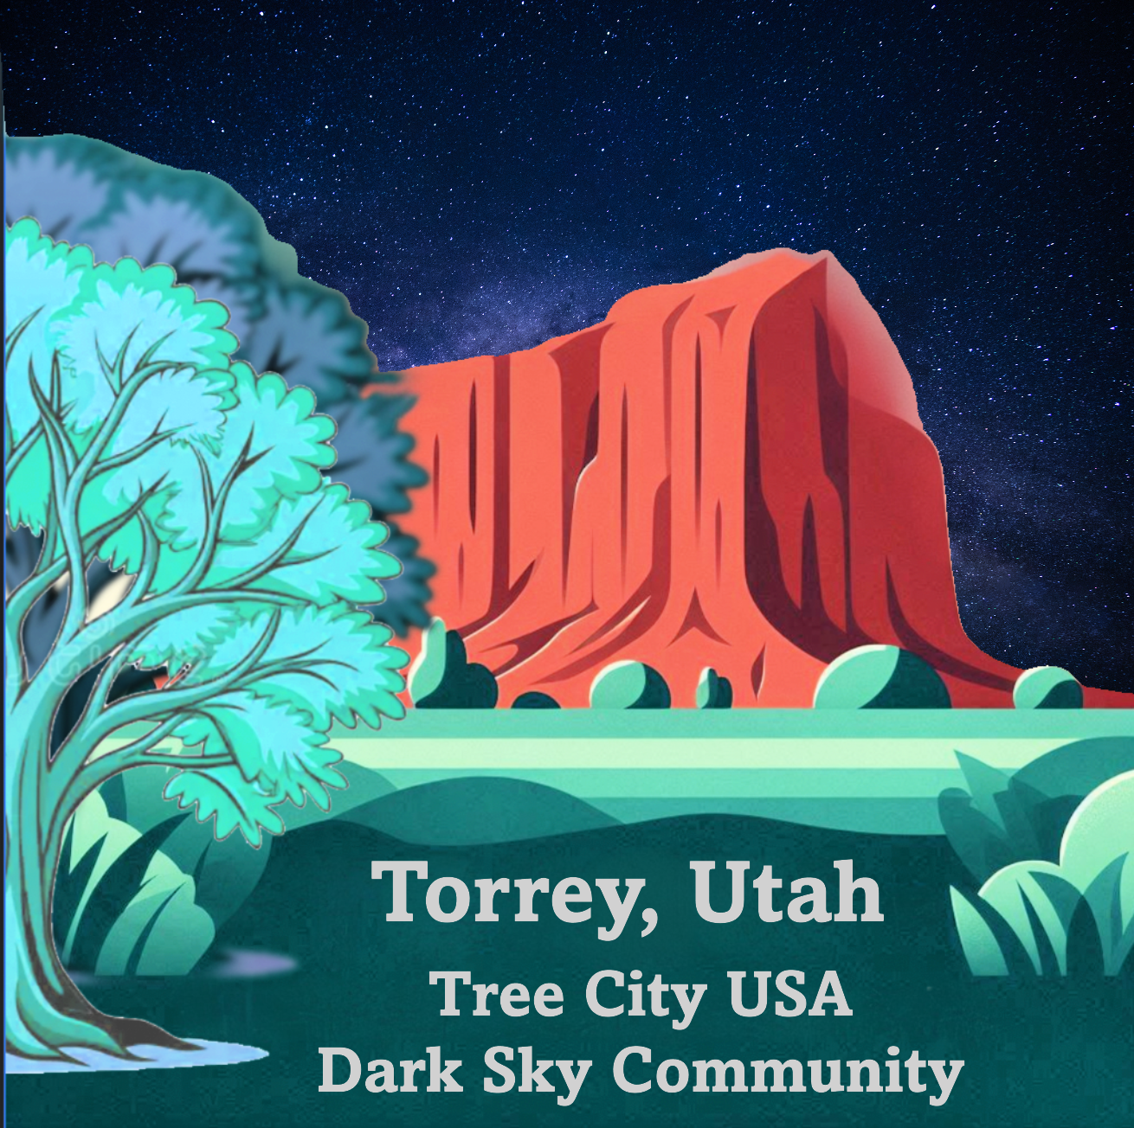
MEMORANDUM OF UNDERSTANDING (MOU)
Between Torrey Town And Tourism Committee
This Memorandum of Understanding (MOU) is entered into on this _____ day of _______, 2025, by and between Torrey Town ("Town") and Tourism Committee ("Committee") with the purpose of establishing a partnership to address tourism in Torrey.

1. Purpose.
The purpose of this MOU is to define the roles, responsibilities, and expectations of both parties in planning, developing, and addressing tourism activities within Torrey.

2. Objectives
To maximize economic contributions of current visitation
To enhance the visibility and appeal of Torrey as a tourist destination
To organize tourism-related events and initiatives
To gather and share information promoting sustainable tourism

3. Responsibilities of the Town
Provide support and resources necessary for tourism activities
Facilitate access to town facilities and public spaces
Assist in promotional efforts through official channels
Ensure compliance with local regulations and policies

4. Responsibilities of the Committee
Develop and implement tourism initiatives and marketing strategies
Coordinate with local businesses, community organizations, and stakeholders
Organize events, campaigns, and visitor engagement activities
Submit regular reports on activities and plans to the Town

5. Funding and Resources
The Town and Committee will determine budget allocations and resource commitments collaboratively. Additional funding may be sought through grants, sponsorships, or partnerships.

6. Duration
This MOU is effective from ________________ and shall remain in effect until ____________, unless terminated earlier by either party with a 30-day written notice.

7. Amendments
Any amendments to this MOU must be made in writing and signed by both parties.

8. Termination
Either party may terminate this MOU by providing written notice 30 days in advance.

9. Miscellaneous
This MOU is not legally binding but reflects the mutual understanding and commitment of both parties.
Both parties agree to collaborate in good faith to achieve the objectives outlined herein.
IN WITNESS WHEREOF, the parties hereto have executed this MOU as of the date first written above.
Torrey Town
By: ___________________________
Name: _________________________
Title: __________________________
Date: __________________________
Tourism Committee
By: ___________________________
Name: _________________________
Title: __________________________
Date: __________________________

