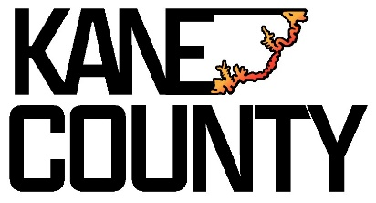
NOTICE OF PUBLIC HEARING

Notice is hereby given that the Kane County Commission will hold a public hearing on Tuesday, September 30, 2025, at 10:00 a.m. in the Commission Chambers at the Kane County Courthouse, 76 North Main Street, Kanab, Utah.
The purpose of the hearing is to consider and take public comments on a proposal for the creation of an agricultural protection area.
The proposed agricultural protection area is located Beginning at the se cor of sec 14 t38s r9w slb&m & run th n 89*32' w 1,317.82 ft; th n 0*01'18" w 1,202.36 ft; th s 67*52'10"e 1,120.03 ft; th s 58*29'54" e 1,106.41 ft; th s 0*42'43" w 246.99 ft; th n 87*04'48" w 660.40 ft to the pt of beg. Reserving unto the grantor, their successors &/or assigns, a perceptual non-exclusive easement along the west 20 ft of said land, adjacent to the Corry property to allow access to develop & maintain the water supply for the remainder of the property retained by Rocki Alice LLC. *being in sec's 13 & 14 t38s r9w*. Parcel Number 8-9-14-3. Containing approximately 34.83 acres
There are no proposed modifications to the proposed agriculture protection area.
The advisory committee and the planning commission each evaluated the proposal using the criteria in Utah State Code 17-41-305 and recommends approval for this Agricultural Protection Area proposal.
Interested persons may appear at the public hearing and speak in favor of or against the proposal, any proposed modifications to the proposal, or the recommendations of the advisory committee and planning commission.
Written comments may be submitted to:
Kane County Commission
76 North Main Street
Kanab, UT 84741
Email: commission@kane.utah.gov
Dated this 15th day of September, 2025.

____________________________________
Chameill Lamb
Kane County Clerk Auditor

76 North Main Street
Kanab, Utah 84741
(435) 644-2458
clerk@kane.utah.gov

View online at https://meet.google.com/rbr-dzqe-eav

