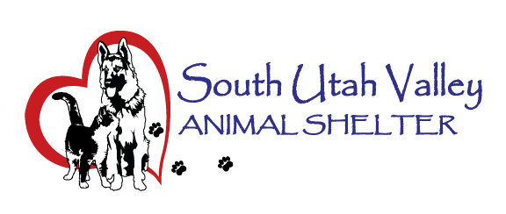
South Utah Valley Animal Special Service District
Board Meeting Minutes Tuesday July 15, 2025
South Utah Valley Animal Shelter Conference Room
582 W 3000 N Spanish Fork UT 84660
Board Member Attendance
Lt. Laursen* Chief Rod Hurst @RandiLyn Warner
Chief Lance Haight* Chief John Jackson* @Dr Bott
LEO Phil Christensen Chief Brad Bishop @Legal-not filled
Kari Malcovich Kevin Oyler Shawn Carter
SUVAS Executive Director: Minutes:
Kierstan Munford (*Absent / @ At large) Carrie Ward
The meeting was called to order at 10:34 AM by Chairman Rod Hurst.
There was one member of the public present; Tom Sinnott from BF.
- Approval of minutes of Board Meeting held on 5/20/2025. Motion to approve the minutes. 1st Kari Malcovich, 2nd Kevin Oyler. Motion passed unanimously.
- Discussion of Animal Shelter building lease. Extending the lease was discussed, new locations were discussed and the possibility of a third District being created. The lease was reviewed by Board Members.
- Financial Report by Kierstan Munford. The new Budget was handed out and reviewed.
- Shelter Report by Kierstan Munford. We have won a $30,000 grant from the ASPCA for targeted adoption dates and foster expansion. This will run from August 1 to October 31. There will be an Event in partnership with Quick Quack soon. Kierstan and Brooklyn will be meeting them this afternoon. The Licensing/Fundraising position has been filled. The animal count this morning was 78 dogs in house, 24 dogs in foster, 140 cats in house with 39 in foster. Chief Hurst asked about the SUVAS grounds and if Kierstan has hired someone to take care of them. Chief Bishop asked if Spring Lake will be coming onboard as its own city and breaking away from Utah County. When they do, they will have to contract the animal services as a city.
- Set date and time for next meeting. The next Board Meeting will be on September 16 at 10:30 AM in the SUVAS conference room.
- Chairman Hurst asked for a motion to adjourn. Motion to Adjourn. 1st Kevin Oyler, 2nd Chief Bishop. Motion passed unanimously at 11:14 AM.

