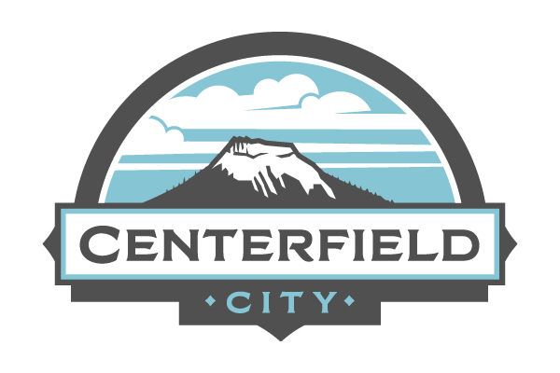
PUBLIC NOTICE
Centerfield City – 2025 Municipal Election Update
Pursuant to Utah Code Annotated § 20A-1-206, the Centerfield City Council has adopted Resolution No. 2025-6, cancelling the races for Mayor and City Council in the November 4, 2025, Municipal General Election.
All candidates for these offices were unopposed and are therefore declared elected:
- Travis B. Leatherwood, Mayor
- Sherry Louise Fraiser, City Council Member
A second City Council vacancy, for which no candidate filed, will be filled in accordance with Utah Code Annotated § 20A-1-510
Important: The election on Proposition #10 – Recreation, Arts, and Parks (RAP) Tax Reauthorization will still be held on November 4, 2025.
For questions, please contact the Centerfield City Recorder’s Office.

