DRAFT CITY OF OREM
DEVELOPMENT REVIEW COMMITTEE MINUTES
September 2, 2025

The following items are detailed in these minutes:
- Administrative Site Plan Approval – F3 Self Storage – 243 South Geneva – Approved

Place: Aspen Conference Room (Floor 2) – City Hall Building – 56 North State Street, Orem Utah, 84057

11:02 a.m. Jared Hall called the meeting to order.

Those Present: Derek Spencer, Jared Hall, Darren Pead, Rick Sabey, Gary McGinn

Those Excused: Rebecca Gourley, Grace Bjarnson, Taggart Bowen, Chelsea Lindsey, Aaron McKnight

- Administrative Site Plan Approval – F3 Self Storage – 243 South Geneva – Approved

Jared Hall introduced the administrative site plan for F3 Self Storage. The project involves the interior remodel of three existing buildings from office space to self-serve storage units. The plan meets all code requirements. The Development Review Committee recommended the administrative site plan for approval.
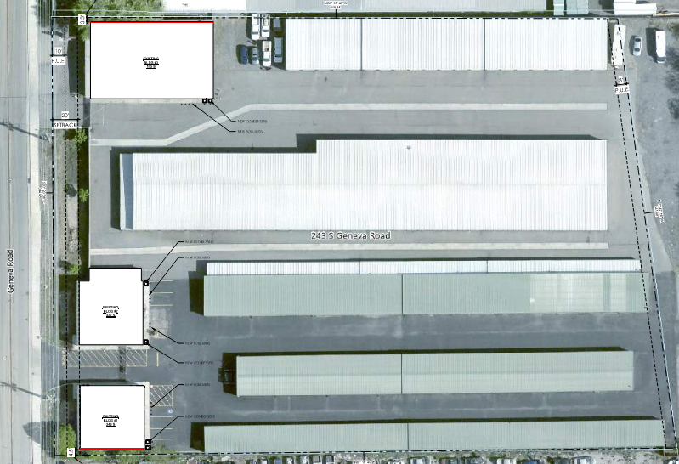

DRC Action: Gary McGinn moved to approve the administrative site plan. Derek Spencer seconded the motion. The motion passed unanimously.
Yes: Derek Spencer, Darren Pead, Rick Sabey, Gary McGinn, Jared Hall
No: None

- Minutes: The minutes from the August 18th DRC meeting were presented for approval. The Development Review Committee approved the minutes.

DRC Action: Derek Spencer moved to approve the minutes. Gary McGinn seconded the motion. The motion passed unanimously.
Yes: Derek Spencer, Darren Pead, Rick Sabey, Gary McGinn, Jared Hall
No: None

- Adjourn:

DRC Action: Gary McGinn moved to approve the minutes. Derek Spencer seconded the motion. The motion passed unanimously.
Yes: Derek Spencer, Darren Pead, Rick Sabey, Gary McGinn, Jared Hall
No: None

Adjourn: 11:06 a.m.
Approved On: draft

