
The Northern Utah Academy for Math, Engineering & Science
Board of Trustees Meeting
May 13, 2025

Attending: Sue Johnson, Becky Frost, Jessica Oyler, Brian Rague, Meghan Dutton, DJ Millar, Laurie Larson, Kelli Booth, Nate Taggart, Dawn Winter, Steve Davis, Brenda Casper, Mindy Nelson, Jared Schneider (DAVIS SBO) Vickie Finlinson
Welcome: Board President, Susan Johnson
ACTION ITEMS:
- Introductions and thank you:
We want to thank Dr. Dave Ferro for serving on our NUAMES Board. He has been wonderful to work with and it has been an honor to have him serve on the board.
- We welcome Dr. Brian Rague, who will be replacing Dr. Dave Ferro on the NUAMES Board of Trustees (in the WSU appointed seat)
- He is the new Dean of the College of Engineering, Applied Science & Technology.
- Dr. Rague brings more than 21 years of experience guiding and promoting Weber State University.
- Dr. Brian Rague has served as Associate Dean of EAST since 2018 and, before that, was Chair of the Department of Computer Science.
- Dr. Rague earned his bachelor’s degree in electrical engineering and computer science from the Massachusetts Institute of Technology, a master’s degree in aeronautics and astronautics from MIT, and a Ph.D. in computer science from the University of Utah.
Introductions of the Board:
- Brenda Casper Principal of NUAMES Davis
- Becky Frost, parent of senior and community council member
- Steve Davis, Principal at NUAMES North
- Nate Taggart, Executive Director of Business Operations
- EJ Millar, Level 7 Marketing. He assists NUAMES with marketing and is a father of a sophomore at NUAMES.
- Laurie Larson, Mother of previous students. She has been involved for 17 years with NUAMES either on community council or as a Board member.
- Brian Rague has been at WSU for 24 years. He is the Chair of Computer Science and is excited to be on the Board.
- Meghan Dutton has been on the Board for 4 months. She is an attorney and works for Caterpillar. She’s a mom of 10- and 6-year-old who she hopes will someday come to NUAMES.
- Mindy Nelson is the Vice Principal of NUAMES North. She was a counselor before pursuing administration.
- Jared Schneider is an officer at NUAMES Davis and will continue in office next school year.
- Vickie Finlinson is the Administrative Assistant for NUAMES.
- Sue Johnson, NUAMES Board President for 22 yrs. Sue gave the history of NUAMES. Her key feeling is that she wished every kid in the state of Utah deserves a NUAMES education!
- Dawn Winter is the Director of Student Services. She supervises school counseling, SPED, and 504s.
- Keli Booth is the Executive Director of NUAMES. She is passionate about NUAMES as all 4 of her boys are NUAMES graduates (with the 4th one graduating on Friday). NUAMES transformed her children.
- Jessica Oyler is Weber State University’s VP of Student Success. She has been on the Board for one year
Sue introduced those not in attendance:
- Mary McKinley was the Executive Director of the Ogden Nature Center.
- Lynnette Gilbert who has a son that was our first valedictorian. He has become very successful.
- Michelle Bues is a lawyer and on the State Board of Education. Her specialty is policy, and she is a great help to us here.

- MEETING MINUTES: Sue Johnson
Motion to approve Minutes from January 7, 2025: Becky Frost. Second: Meghan Dutton. All in favor.

- Time and Effort Policy and Procedure: Nate Taggart
  - For NUAMES, this tracks teachers who are mostly part-time SPED teachers and regular ed teachers. The State needs to make sure the money is going to the proper programs.
  - Sue asked how many SPED teachers we have. We have one on each campus. It’s easy with them because they are both full-time special education teachers. We have around 50 students in the SPED program at both schools.
Motion to approve the Time and Effort Policy: Sue Johnson. Second: Meghan Dutton. All in favor.

- Fraud Risk Assessment: Nate Taggart
- With the Fraud Risk Assessment, they take off points if we aren’t doing certain things. Nothing happens if we are doing it. There is separation of duties and there are other eyes on this. We wanted to mention to the Board, we thought we could give ourselves full credit if we make a change: There is a training for new Board members. Nate sent an email earlier this morning to each of you which contains a link to that training. It goes over audits, general fiduciary responsibilities, etc. This takes about 35 minutes to take. There are things we gave ourselves full credit on. A Board member has 4 years to take the training, but we wanted to get it done soon. Thanks for doing this.
Motion to approve Fraud Risk Assessment: Laurie Larson. Second: Becky Frost. All in favor.

- Open Meetings Training: Nate Taggart
For this training, there is 7 minutes of training and then a test. This was on the email that went out on board meeting. We ask the Board to please take this test. Thank you. Our Board does a great job of being open.

- Head-Related Injuries Policy: Kelli Booth
- All schools are required to have this policy. We ran it through our legal counsel. Heidi Alder has reviewed this. If a student has a head-related injury, we see what support we should give. If there is a report of something, we now have a policy. This is the state’s model policy. We have always accommodated for concussions, but now we have the policy for it. This is good for kids who play sports or ski.
Motion to approve the Head-Related Injuries Policy: Sue Johnson. Second: Meghan Dutton. All in favor.

- Human Sexuality: Kelli Booth
- We have had no complaints. Our committee members are health, biology and science teachers. We haven’t had complaints.
- All teachers use USBE-approved curriculum.
- All teachers have received USBE training. We never bring in guest-lecturers or speakers. We have had students opt out and they have an alternative assignment. Parents receive notification when this happens.
- Our committee members are Michelle Christensen, Kelli Booth, Dawn Winter, Brenda Casper, Mindy Nelson, Jen Shelton, Nickole Brooks, Heather Bess and Jon Simerick.

- Land Trust Plan: Brenda Casper and Steve Davis
NUAMES Davis: Brenda Casper
- Goal #1: Enhance student safety through emergency communication and medical preparedness.
- Action Plan: Purchase and distribute wearable panic buttons for all faculty and staff. $25,000. Purchase and install “Stop the Bleed” first-aid kids in classrooms, hallways, and high-traffic areas. $3,000.
- Goal #2: Increase student proficiency in Math and Science as measured by ASPIRE test scores by 2% and demonstrate a measurable improvement in ACT performance by .2%. We will maintain a graduation rate of 97% or higher.
- Action Plan: Math Boot Camp $2,000. ACT Boot Camp $1,000. Two Laptop Carts $60,000. Tutoring Program $13,274.72. Total: $104,274.72

NUAMES North: Steve Davis
- Goal: Current baseline data in Math and Science will be used to measure academic progress. Continue the increase in growth rate and proficiency levels in mathematics. Provide intervention and tutoring for students in all content areas. Identify students with low academic levels and provide targeted interventions. NUAMES North will increase Math and Science ASPIRE scores by 5% and show an increase in ACT scores. We will also see an increase in the Lexile Level for our 10th graders. We will continue to have 100% of our students graduate.
- Action Plan: Increase technology support in the STEM areas and support student learning. We will purchase 1 computer lab for Math. These new computer labs will increase student learning by ensuring they have the technology needed to access our online curriculum and course content. $37,600. NUAMES will continue the established tutoring program to assist students in all academic areas. $25,000. IXL Reading/Math assessment program. $7,500. Total $70,100.00.
Motion to approve Trust Land Plans: Laurie Larson and Sue Johnson. All in favor.

- Counseling Data Project: Dawn Winter
The State Office of Education provides a school counseling program. There is money that comes with it, and we must do a data project each year. You can see the success of it by the numbers. Our counselors are the ones who got students into early college. See below. This is the 2025 graduating class. Students participated in both Fall and Spring semesters. This is one of the requirements: That this project as presented to School board every year.

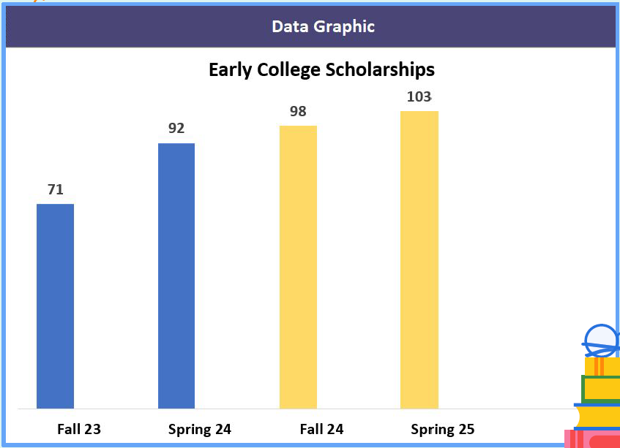

- Student Achievement: Steve Davis
Steve reviewed the ACT scores. See the improvement of NUAMES Davis. or a school to jump an entire point is phenomenal. We are so proud of our students and their achievements. This year we had 7 students from NUAMES Davis who achieved a “36” on their ACT. NUAMES North had 2 students with a “36”.

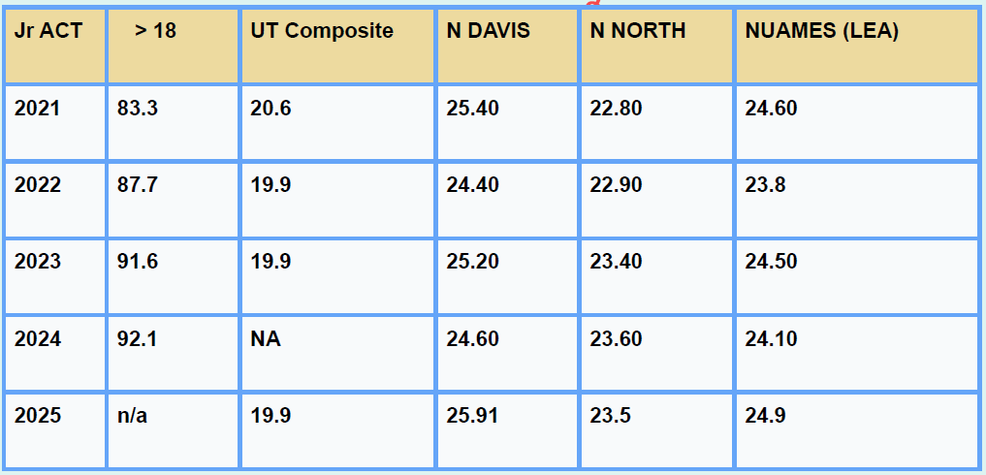

- ACT Student Achievement: Steve Davis
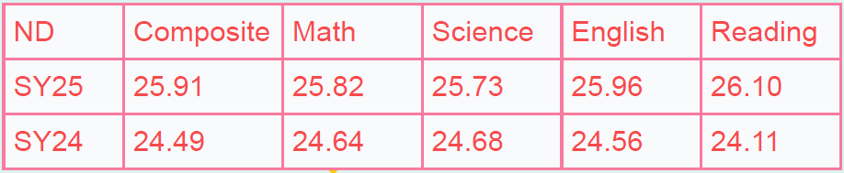
65 Students got a score above 30. 73% of students qualified for their College Math QL.
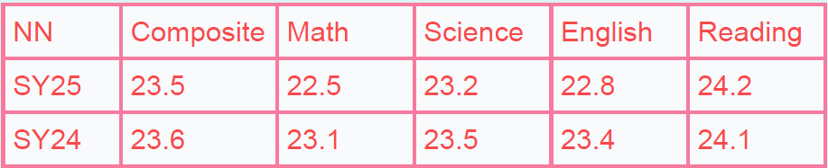
National Merit: NUAMES DAVIS: 4 NUAMES NORTH: 2
- Graduation Statistics: Dawn Winter
NUAMES DAVIS:
Total Seniors: 197
High Honor Roll: 45
Honor Roll: 37
42% of Seniors in Honors or above.
Associate Degrees: 122
Certificate Earned: 24
DAVIS/OTECH – 27
74% of Seniors completed the Higher Education Program

NUAMES NORTH:
Total Seniors: 141
High Honor Roll: 22
Honor Roll: 19
29% or Seniors Honors or above
Associate Degrees: 76
Certificate Earned – 7
OTECH: 17
71% of Seniors completed the Higher Education Program
Total amount of Scholarship money:
Davis $4,961,593.91
North $2,927,817.96
TOTAL Scholarships earned: $7,889,411.87

Weber State provided scholarships also. 55 students received the Presidential Scholarship. Thanks go out to our Counseling Departments. They work so hard for struggling students, they forget how amazing and how hard the others are working. The numbers matter. We do many things to prepare our students to attend University.

- Accreditation Report: Kelli Booth
  - NUAMES Score – 364
  - Network Average – 296
  - NUAMES score 5 years ago – 340
  - SCORING: They turn over every leaf and examine our school. We had over 200 articles of evidence. The average network score is 296. We received 340 five years ago. It was the highest score the Accreditation Committee had ever seen for a high school. They interview many administrators, parents, and teachers. We received the highest on culture of learning. See below:

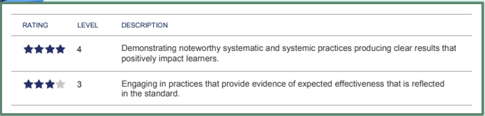

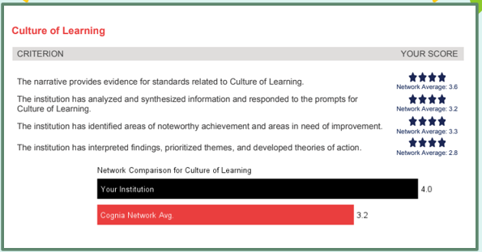
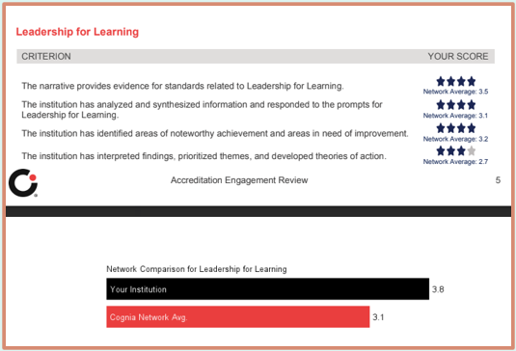
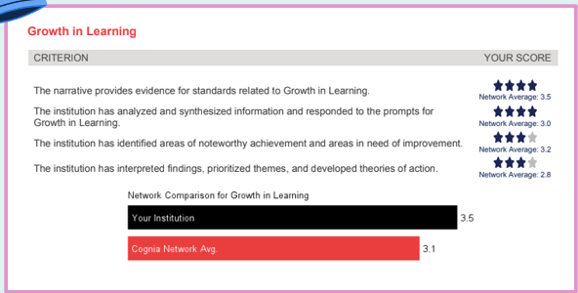
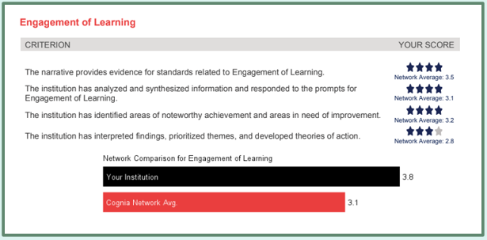

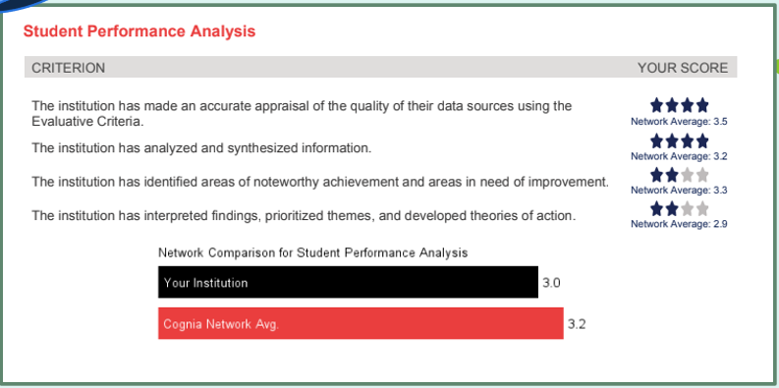

- Lottery – SY26: Brenda Casper
NUAMES DAVIS NUAMES NORTH
New Students New Students
Sophomores: 300 Sophomores: 134
Juniors: 223 Juniors: 186
Seniors: 241 Seniors: 165
TOTAL: 764 TOTAL: 485

ND & NN Total – 1,250

- Davis Tech and NUAMES
  - NUAMES will have a classroom and office on the Davis Tech Campus.
  - They will have the Cyber Security Pathway.
  - We lost our Cyber Security teacher to WSU. We have gone years without cyber security. We asked if we could contract with Davis Tech bringing their Cyber Security classes on the Davis campus. Then we will turn them over to WSU. Davis has provided an office and a classroom on that campus. They gave us a beautiful classroom. We can service our students on that campus. We have 50 currently and are continuing to register for the Cyber Security Pathway. They are so excited about this stackable pathway with Davis Tech. Architecture, Web Development, and Cyber Security are some of the pathways. Stack them with NUAMES, D-Tech and Weber State University. Our students can do all three at the same time. We have worked hard to make sure this partnership is articulated back to WSU for this credit. Kelly Simerick worked for Weber State before she went to D-Tech. She knows our goal. Students will come back to WSU and continue. We can work with three institutions.

- Graduation: Kelli Booth
  - Date: May 16, 2025
  - Time: 10:00 am
  - Location: Dee Events Center
  - Please arrive on stage by 9:45. We have seats for all of you on stage. If you can’t come let us know.

Next Meeting: June 23, 2025 10:00 am via zoom

Motion to adjourn meeting: Laurie Larson. Second: Sue Johnson.

