Monthly Fire District Report EMS

Transports for the Year
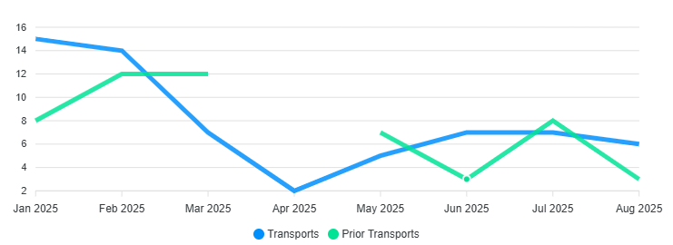
Billing
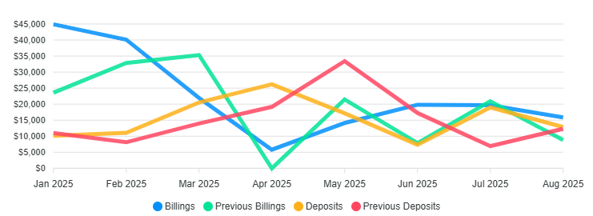

2025
Transports 64 / Billed $182,265.21 / Collected $124,265.65 / YTD

2024 Totals
Transports 74 / Billed $212,292.64 / Collected $150,340.23 /2024

Monthly Calls for Service
NFFD Trends

325
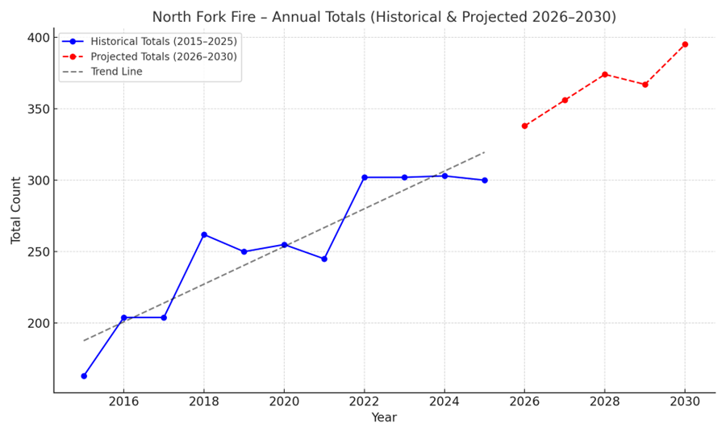
85% Increase in call volume over the past 10 years
3 Year Monthly Call Average /16.6 41 Calls , Calls year to date 240
ISO, WUI, and the North Fork Fire District

🔹 ISO Ratings (Insurance Services Office – PPC)
• Public Protection Classification (PPC) rates fire protection from 1 (best) to 10 (worst).
• North Fork Fire District: ISO PPC = 4 → strong protection for a rural district.
• Benefits residents with lower premiums compared to higher PPC areas.
• Scoring factors: dispatch, fire department staffing/equipment/training, water supply, and prevention programs.
• For rural Utah: water shuttles/tenders, automatic aid agreements, and documented training are key to maintaining/improving PPC.

🔹 Wildland–Urban Interface (WUI)
• Definition: Where structures and vegetation meet/mix; highest wildfire risk.
• Utah context: ~93% of WUI land is still undeveloped, but growth is rapid in northern counties.
• Impact: Homes in WUI zones often face higher insurance costs or policy nonrenewals.
• Mitigation (defensible space, Firewise USA neighborhoods, wildfire-resistant construction) can reduce risk and preserve insurability.

🔹 North Fork Fire District & WUI
• Covers rural WUI areas (Provo Canyon foothills and surrounding wildlands).
• Challenges: limited hydrants(Not NFFD), rugged topography, high wildfire exposure.
• Opportunities:
- Use UWRAP (Utah Wildfire Risk Assessment Portal) and Open Data WUI maps to identify high-risk neighborhoods.
- Support Community Wildfire Protection Plans (CWPPs) and Firewise programs to strengthen resilience.
- Communicate mitigation work to insurers for premium relief.
- Apply for state/federal grants (Utah FFSL, FEMA BRIC) to support WUI defense.

🔹 Policy Outlook (HB 48 – 2025/2026)
• Redefines High-Risk WUI boundaries based on Structure Exposure Scores (SES).
• Requires insurers to use state WUI designations in premium decisions and disclose WUI status to homeowners.
• Will directly affect many North Fork FD residents starting in 2026.

✅ Bottom Line:
North Fork FD’s ISO Class 4 rating shows strong fire protection, but WUI exposure drives insurance challenges. Using UWRAP tools, mitigation programs, and HB 48’s new framework, the district can help residents balance insurance affordability with wildfire safety.

Insurance Market Trends in Utah

Since 2019, Utah homeowners have experienced a 54% increase in insurance costs, partly due to elevated wildfire risk and broader industry shifts
(KSL.com)

Insurers have begun dropping high-risk clients in wildfire-prone areas; however, unlike some states, Utah residents generally remain able to find a new carrier, albeit at higher premiums
(KUER)

State legislative efforts (e.g., HB 48) aim to redefine wildfire risk zones using Utah-specific data, potentially reducing the number of residents deemed high-risk (currently ~300,000 residents labeled “WUI”—the bill may reduce that to ~70,000) (KSL.com)

Wildland Revenue/Info 2025
Gross

Notes of Interest

*PARKING PROBLEMS*
NON-EMERGENCY # Utah County Sheriff’s Office: (801) 851-4100
NON-EMERGENCY # UHP Salt Lake/Utah County: (801) 887-3800

