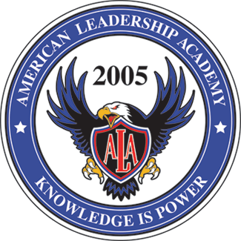

American Leadership Academy
Board of Trustees/Charter Trust Lands Council Meeting Agenda
September 10, 2025 6:00pm
ALA Junior High Upstairs room 226

Subject________________________________________________________________________
Approval of Board Minutes from 8-27-25

RMorley Presents:
Field House Update
Board Training Report
4-day Week Renewal

David Robertson Presents:
ALA Bond

LNichols Presents:
Update on fees - ESports

JDavis Presents:
Policy Reasonable Force Seclusion and Restraint
Policy Salary Supplement for High Need Educators
Land Trust Amendment
TSSA Plan
LEA Specific License Assignments

BPeterson:
Board of Trustee Business

Open Public Discussion -

Closed Meeting:
Potential Board Member Interview
Board Member Character Discussion

Open Meeting:
New Board Member Vote

