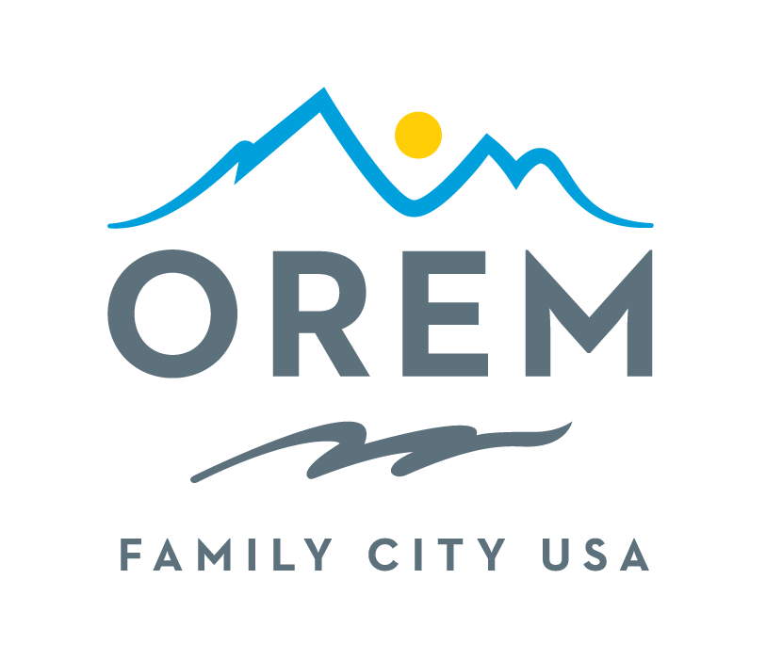
CITY OF OREM
ADVISORY BOARD/COMMISSION
MEETING AGENDA

This meeting may be held electronically to allow a board/commission member to participate.
PUBLIC BODY: Events Advisory Commission
DATE: Thursday, September 11, 2025 ROOM: City Council Conference Room #1002
Right next to the City Council Chambers
TIME: 4:00 p.m. - 5:30 p.m. ADDRESS: 56 North State Street, Orem, Utah

AGENDA ITEMS:

Welcome Ashlie Mann

Review and Approve Minutes from July 10, 2025 Ashlie Mann

- City Updates
  - Google Groups Training Jake Gould
  - Events Commission – Position Description Guide Kenice Whitaker
  - New Orem Boards and Commission Page – https://orem.gov/boardscommissions
  - Requests Kenic Whitaker
- Commission Updates
  - Action Commitment Reporting Ashlie Mann
  - Asks Ashlie Mann
- Discussion Items
  - Taste of Orem
    - Entertainment Ashley Shumway
    - Art Vendors Ashlie Mann
    - Cultural Booths Krista Tate
    - Food Vendors Sydney Bailey
    - Logistics and Safety Kenice Whitaker
  - Fall and Winter Events (Help Needed) Kenice Whitaker & Sydney Bailey
    - Veteran’s Day
    - Gold Star Memorial Dedication (TBA)
    - Truck and Treat
    - Lights On
- Review Action Commitments Kenice Whitaker

Next Meeting – October 9, 2025 Ashlie Mann
Adjournment Ashlie Mann

THE PUBLIC IS INVITED TO PARTICIPATE IN ALL CITY MEETINGS.

If you need special accommodation to participate in Advisory Commission meetings
Please contact us on the City's website at orem.org or call (801) 229-7000 at least three working days.
prior to the meeting. This agenda is available on the Utah Public Notice website at utah.gov/pmn.

