BEAVER HOUSING AUTHORITY
BOARD MEETING AGENDA
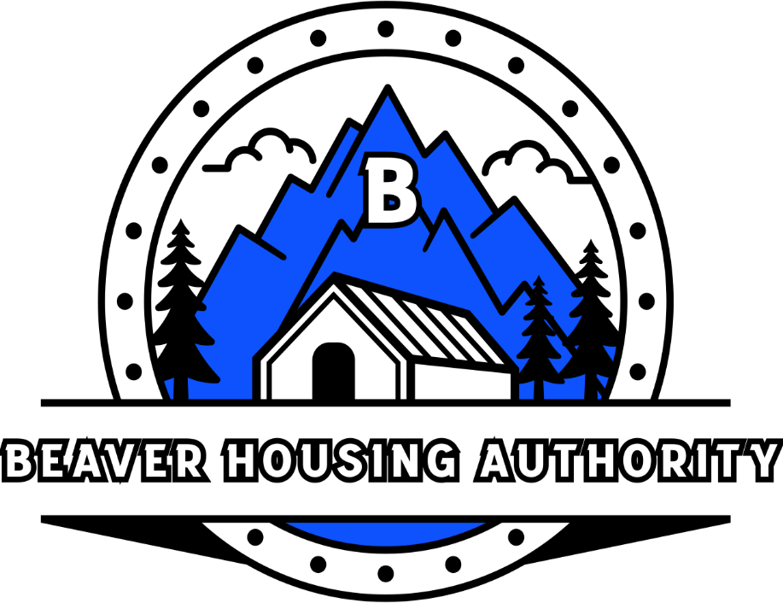
September 9th, 2025

- Welcome

- Prayer
- Attendance
- Bills
- Minutes
- Administrative Plan – Housing Choice Voucher & Mainstream Voucher (Section 8) – Approval - Resolution
- ACOP (Admissions and Continued Occupancy Policy) – Public Housing – Approval - Resolution
- Beaver Housing Authority Personnel Policy - Resolution
- Beaver Housing Authority Procurement Policy - Resolution
- Beaver Housing Authority Bylaws – Resolution
- Dissolution of LLC – CROWN @ Beaver City II
- Dissolution of LLC – CROWN @ Beaver County
- Program Updates:
  - Public Housing
  - USDA
  - LIHTC (Beaver & Milford Meadows)
  - CROWN Programs
  - Development (Property Management)
  - Section 8 (HCV & MS)
- Adjourn

