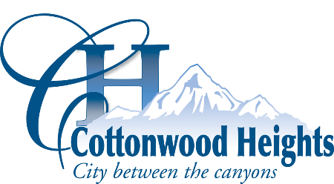

HEALTH IN THE HEIGHTS COALITION MEETING AGENDA

Notice is hereby given that the Health in the Heights coalition, the city’s public health coalition, will meet on September 8, 2025, at 4:00 p.m., in the Community Room at Cottonwood Heights City Hall (2277 E. Bengal Blvd., Cottonwood Heights, UT 84121).

4:00 p.m. | Welcome
4:05 p.m. | Get Healthy Utah  - Update on Healthy Community designation  - Next steps
4:15 p.m. | Community Board Orientation  - Communities that Care Community Board Orientation Module 1, Session 3  - Communities that Care Community Board Orientation Module 1, Session 4
6:00 p.m. | Adjourn

On Friday, August 29th, 2025, a copy of the foregoing notice was posted in conspicuous view in the front foyer of the Cottonwood Heights City Offices, Cottonwood Heights, Utah. The agenda was also posted on the City’s website at www.cottonwoodheights.utah.gov.

DATED THIS 29th DAY OF AUGUST 2025 Tiffany Janzen, City Recorder

In compliance with the Americans with Disabilities Act, individuals needing special accommodations or assistance during this meeting shall notify the City Recorder at (801)944-7021 at least 24 hours prior to the meeting. TDD number is (801)270-2425 or call Relay Utah at #711. If you would like to submit written comments on any agenda item, they should be received by the Health in the Heights mailbox no later than Tuesday at noon. Comments can be emailed to HIHCoalition@ch.utah.gov

