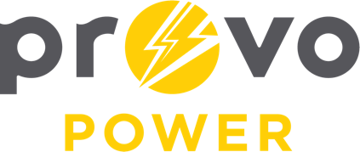
AGENDA
ENERGY BOARD MEETING
PROVO POWER
251 W 800 N
Monday, September 8, 2025
4:00 P.M.

- Welcome & Introductions – Chairman Gary Winterton
- Review & Approval of Minutes – August 4, 2025
- Open and Public Meetings Act (OPMA) Training – Matt Griffiths
- Financial Report – Charlie Little
- KPI Report – Charlie Little
- Manager Report – Scott Bunker
- Calendar & Scheduling
  - NatureShade Event: September 18th, 2025
  - Public Power Fair: October 2nd, 2025
  - Next Board Meeting: November 3rd, 2025

A copy of the agenda was posted in the Civic Center, and the Provo City Library, on September 3, 2025, and also delivered to the Mayor,
City Council Members, required news media, and adjacent cities in
compliance with the Utah Code 52-4-202

