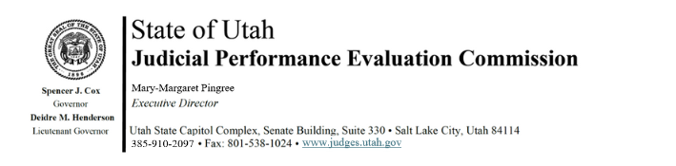
Tuesday, September 9, 2025
9:00 am-12:00
Hybrid Meeting *

Members: Lisa Watts Baskin, Mallory Bateman, Christine Durham, Christian Hansen, Blair Hodson, Curtis M. Jensen, Sonya Martinez-Ortiz, Gil A. Miller, Mary Noonan, Bridget Romano, Tom Ross, Mike Smith

Staff: Madison Klein, Jamie Nelson, Chris Russell, Mary-Margaret Pingree

9:00 a.m. Welcome Bridget Romano
Approval of Minutes – July 8, 2025

9:05 a.m. Updates & Announcements Mary-Margaret Pingree

9:10 a.m. Evaluation Prep Mary-Margaret Pingree
Chris Russell

9:40 a.m. Disclosures/Recusals/Disqualifications Mary-Margaret Pingree

10:00 a.m. JPEC Review Committee/Interim Meetings Bridget Romano

10:45 a.m. Statute Changes Mary-Margaret Pingree

11:30 Adjourn

Next Meeting: Thursday, November 13, 2025
9:00 a.m. – 12 noon
Large Conference Room, 3rd Floor, Senate Building
*Anchor Location: Senate Building, Suite 330, CCJJ Large Conference Room

